
Panel reference | PPSSWC-311
DA Number | DA-975/2022
Proposed Development | Concept Development Application for warehouses, food & drink premises, service station, and associated access, car parking, landscaping and fencing, signage, civil works including stormwater management, earthworks, demolition, dam de-watering, tree removal, utility services connections, and subdivision for part road dedications, to be delivered in stages.  The DA includes the first stages of development involving subdivision, civil works across the whole site, and design and construction of two warehouse buildings with associated vehicle access, parking, landscaping, fencing, signage and utilities connections.
Address | Lots 384 & 385 DP 2475 and Lot 8 DP 235953  575, 585, 595-599 Fifteenth Avenue, Austral
Applicant | The Trustee for The Austral Heights Discretionary Trust
Owner | Owner 1: Austral Heights Pty Ltd  Owner 2: Van Bao Nguyen, Thi Thom Nguyen and Thanh Cuong Nguyen
DA Lodgment Date | 21 September 2022
TOTAL & UNIQUE SUBMISSIONS KEY ISSUES IN SUBMISSIONS | Nil
Application Date | Concept and Stage 1 DA
Regionally Significant Criteria | Clause 2, Schedule 6 of State Environmental Planning Policy (Planning Systems) 2021: Development that has a capital investment value of more than $30 million.
CIV | $37,541,979 (excluding GST)
CLAUSE 4.6 REQUESTS | Building height limit in clause 4.3 of the SEPP (Precincts – Western Parkland City) 2021 – IN2 Light Industrial Zone
List of All relevant Section 4.15(1)(a) matters | List all of the relevant environmental planning instruments: Section 4.15(1)(a)(i)  SEPP (Precincts – Western Parkland City) 2021  SEPP (Resilience and Hazards) 2021  SEPP (Biodiversity and Conservation) 2021  SEPP (Transport and Infrastructure) 2021  SEPP (Industry and Employment) 2021
RECOMMENDATION | Approval with conditions
List all documents submitted with this report for the Panel’s consideration | Attachment A: Draft Consent and Conditions  Attachment B: Architectural Plans  Attachment C: Clause 4.6 Request  Attachment D: Table of Compliance with Liverpool Growth Centre Precincts Development Control Plan  Attachment E: Civil Plans  Attachment F: Statement of Environmental Effects  Attachment G: Stormwater Plans
SPECIAL INFRASTRUCTURE CONTRIBUTIONS (S7.24) | Conditions of Consent have been imposed for this to be paid.
PREPARED BY | Andrew Wilson – NSW Planning Manager at APP (planning consultant)

Summary of s4.15C matters  Have all recommendations in relation to relevant s4.15C matters been summarised in the Executive Summary of the assessment report? | Yes
Legislative clauses requiring consent authority satisfaction  Have relevant clauses in all applicable environmental planning instruments where the consent authority must be satisfied about a particular matter been listed, and relevant recommendations summarized, in the Executive Summary of the assessment report?  e.g. Clause 7 of SEPP 55 - Remediation of Land, Clause 4.6(4) of the relevant LEP | Yes
Clause 4.6 Exceptions to development standards  If a written request for a contravention to a development standard (clause 4.6 of the LEP) has been received, has it been attached to the assessment report? | Yes
Special Infrastructure Contributions  Does the DA require Special Infrastructure Contributions conditions (S7.11EF)?  Note: Certain DAs in the Western Sydney Growth Areas Special Contributions Area may require specific Special Infrastructure Contributions (SIC) conditions | Yes
Conditions  Have draft conditions been provided to the applicant for comment?  Note: in order to reduce delays in determinations, the Panel prefer that draft conditions, notwithstanding Council’s recommendation, be provided to the applicant to enable any comments to be considered as part of the assessment report | Yes

- EXECUTIVE SUMMARY
  - Reasons for the report

The Sydney Western City Planning Panel (SWCPP) is the determining body as the development has a Capital Investment Value (CIV) in excess of $30 million, pursuant to Clause 2 of Schedule 6 of the State Environmental Planning Policy (State and Regional Development) 2011. The CIV is $37,541,979 (excluding GST).

  - The proposal
A Concept Development Application (DA) has been lodged with Liverpool City Council for the staged development of a 5.6151 hectare site zoned IN2 Light Industrial at 575-599 Fifteenth Ave, Austral comprising:
- two warehouse buildings containing 13 units / tenancies and ancillary office space;
- food & drink premises in six separate buildings with 7 units/tenancies including 2 units/tenancies with drive-through take-away;
- service station and attached food & drink premises unit/tenancy in one building; and
- associated vehicle access, car parking, landscaping and fencing, signage, and civil works that includes stormwater management, earthworks, dam dewatering, demolition, tree removal, utility services connections and subdivision for future road widening and part road dedications.
The Concept DA includes the design, construction and carrying out of the first stages of development involving subdivision, civil works across the whole site, and design and construction of two warehouse buildings with associated vehicle access, parking, landscaping, fencing, signage and utilities connections.
Future stage DA/s are required for the design, construction and carrying out of the food and drink premises, service station, and their associated vehicle access, car parking, landscaping and fencing, signage, and utilities connections.
The gross floor areas of the land uses in the proposed development are:
Land uses | Gross Floor Area
Warehouse  ancillary office | 20,630 sq.m 2,705 sq.m
Food and drink premises | 2,105 sq.m
Service Station | 230 sq.m

The staging of construction proposed in the DA is as follows:
Stage | Development works
Stage 1 | - Provision of vehicle access off Fifteenth Avenue  - Demolition of existing structures.  - Dam-dewatering.  - Removal of trees and vegetation.  - Bulk earthworks and site remediation.  - Internal access road and carparking area with associated services  - Construction of a temporary detention basin at the north-western corner of the site.  - Construction of two warehouses with 11 units with associated offices, signage and landscaping.  - Subdivision to create 1 Torrens Title industrial lots and 4 residue lots for future road dedications.
Stage 2 | - Construction of 9 food and drink premises and service station with associated vehicle access, car parking and landscaping.
Stage 3 | - Stage 3 will commence after the precinct detention basin is constructed and operational.  - Decommissioning of temporary stormwater management basin and temporary level spreader.  - Construction of below ground tank with cartridge system to provide permanent on-site water quality treatment, and discharge to Council’s precinct stormwater system in the adjoining road reserve.  - Relocation of driveway on north west corner, and re-landscaping of superseded driveway location.  - Construction of the remaining 2 warehouse units with associated offices.

The main characteristics and attributes of the site are:
- located in the Austral growth centre precinct which is currently characterised as being in transition from rural and rural residential uses to urban uses;
- zoned IN2 Light Industrial Zone;
- frontage to Fifteenth Avenue which is planned to become a future east-west main road corridor to and from the Aerotropolis and Western Sydney Airport;
- comprises three existing lots with a total area of 5.6151 hectares and dimensions of 193.8m in width and approximately 290m in depth;
- existing uses are currently rural and rural residential purposes with existing building structures that include dwelling houses and various rural sheds and structures;
- utility services of water, electricity, and telecommunications only are available at the site;
- topography is gently sloping with a cross fall of 8.2m from the highpoint at RL 67.5 near the centre of the southern part of the site to the low point at RL 59.3 on the north west corner;
- vegetation on the site includes clusters of mainly native trees and scattered trees located on different parts of the site;
- biodiversity certification applies to the site allowing development without further biodiversity assessment;
- surrounding development currently comprises rural and rural residential uses;
- adjacent lands to north, east and west are zoned IN2 Light Industrial.
- adjacent land to the south on the opposite side of Fifteenth Avenue
The proposed development with the recommended conditions of consent complies with the provisions of the relevant planning instruments including the following:

- SEPP (Precincts – Western Parkland City) 2021 provisions that include the objectives and permissible uses in the IN2 Light Industrial Zone, maximum 1:1 floor space ratio, preservation of trees, heritage conservation, and utilities infrastructure;
- SEPP (Resilience and Hazards) 2021 provisions in Chapter 4 Remediation of Land and Chapter 3 Hazardous and Offensive Development;
- SEPP (Biodiversity and Conservation) 2021 provisions in Chapter 2 Vegetation in Non-Rural Areas and the saved provisions for the DA in Chapter 9 Hawkesbury Nepean River;
- SEPP (Transport and Infrastructure) 2021 provisions for development with frontage to a classified road, road noise and vibration, and traffic generating development;
- SEPP (Industry and Employment) 2021 provisions in Chapter 3 Advertising and Signage
- Liverpool Growth Centre Precincts DCP provisions in Chapter 2 Precinct Planning Outcomes and Chapter 6 Employment Lands Subdivision and Development Controls.
The building height on the northern side of the two warehouse buildings exceeds the 13m building height limit in the SEPP (Precincts – Western Parkland City) 2021 reaching up to 16m on the north west corner. The remainder of the development complies with the 13m building height limit.
A Clause 4.6 Variation report is submitted with the DA justifying the contravention of the building height standard. It demonstrates that compliance with the height standard is unreasonable and unnecessary in the circumstances of this case, and that there are sufficient environmental planning grounds for the departure from the standard. The justification is primarily on the grounds that the height exceedance is due to the existing ground level having a significant slope and the nature of the proposed warehouse development requiring very large and flat building footprints. The Clause 4.6 report also demonstrates the proposed development with the additional height is consistent with planning objectives for the zone, and the additional height will not have any significant impact on the environment or surrounding properties. In particular, a visual impact assessment is submitted with the DA and Clause 4.6 report demonstrating the additional height of the warehouse buildings has minimal impact on the visual landscape. The Clause 4.6 Variation report is adequate in justifying the exceedance of the height standard.
Other key issues in the assessment of the proposed development include the following:
- Food and Drink Premises: The amount of gross floor area proposed for food and drink premises is substantial for an IN2 Zone. An Economic Impact Assessment (EIA) prepared by Location IQ has been submitted which demonstrates the project will not undermine the existing and planner future centres in the locality or the objectives of the zone. The EIA justifies the provision of fuel, convenience and fast food services at the site on the basis of current local demand and workforce demand in addition to expected growth in road traffic, expected catchment population and workforce growth, and the implied growth in retail expenditure across the locality in the growth precinct. Council’s City Economy unit supports the DA following the submission of the EIA. A condition of consent is recommended limiting the amount of floor space for food and drink premises to the area proposed in the Concept DA.
- Urban Design: Council’s City Design and Public Domain unit raised a number of urban design issues with the original DA plans. The applicant submitted amended DA plans and additional information including a visual impact assessment and revised Clause 4.6 Variation report which satisfactorily address the urban design issues raised.
- Vehicle Access and Parking: A number of access issues have been raised in the assessment including in particular the access driveway off Fifteenth Avenue as a future main road, potential for internal vehicle and pedestrian conflict, and a slight shortfall in the total number of car parking spaces. Amended plans for the driveway access and an internal traffic management plan have been submitted which are supported by Transport for NSW and Council traffic engineers. Conditions of consent are recommended to reinforce the vehicle access, parking and internal traffic management requirements.

- Stormwater Management and Flooding: The precinct is subject to a precinct wide stormwater detention plan which has not yet been implemented, and the site and adjacent properties are subject to localised flooding in high rainfall events. A stormwater management plan and report that also addresses flood issues has been submitted with the DA that includes temporary on-site detention and water quality controls. The stormwater management plan and report is supported by Council’s Floodplain Management Engineer and Land Development Engineer following a number of revisions.

- Landscaping and Tree Retention: The DA proposes the removal of a total of 87 trees including numerous trees along the southern side of the site which provide amenity, landscape/streetscape, and microclimate value in a location where there is minimal earthworks proposed and ample opportunity for tree retention. This includes trees identified in the arborist report submitted with the DA as having moderate to high landscape significance and retention value. The applicant submitted amended plans retaining 9 trees along the southern boundary of the site, however, 6 of the 9 trees are in the area identified for future widening of Fifteenth Avenue and likely to be removed with the widening leaving 3 trees on the site which is not satisfactory. A condition of consent is recommended requiring the retention of at least 4 trees on the southern part of the site.

- Adjacent Residential Zone to the south: The proposed development has potential to have an impact on the amenity of the adjacent residential zone to the south of the site on the opposite side of Fifteenth Avenue in terms of lighting, noise, odour, dangerous goods, and construction activity. The impact would be satisfactorily mitigated by the separation distances with Fifteenth Avenue, the low scale of the proposed food & drink premises and service station, the absence of shadow impact or significant view impact, and the recommended conditions of consent for noise mitigation measures in the approved Acoustic Report to be implemented, and for a lighting plan, odour report, preliminary hazard analysis and construction management plan to be prepared for the relevant stages of development.

- Setback to Fifteenth Avenue: The proposed development was amended in revised plans with a 20m reserve for the purpose of road acquisition based on advice from Transport for NSW concurrence. However, the revised plans propose building envelopes on the boundary of the future 20m reserve and the buildings are not setback as per control 4.6.3 in the Grow Centres DCP which requires a minimum 7m setback. Therefore, a condition of consent has been imposed requiring design changes to the proposal prior to the issue of a construction certificate which provide a minimum 7m front setback from the proposed road reserve boundary, that has been imposed by TfNSW in their concurrence.

The application was placed on public exhibition from 4 November 2022 to 5 December 2022 with no submissions being received.

Submissions have been received from the NSW Rural Fire Service, Sydney Water and Endeavour Energy that include recommended conditions of consent that are included in the draft consent notice.

Following a detailed assessment of the proposal, pursuant to Section 4.16(1)(a) of the EP&A Act, DA-975/2022 is recommended for APPROVAL subject to the conditions contained at Attachment A of this report.

- THE SITE AND LOCALITY

  - The Site

The site is located at 575-599 Fifteenth Avenue, Austral in an IN2 Light industrial Zone in the growth precinct characterised by transition from rural and rural residential uses to urban uses.

The site comprises three allotments with title description being Lots 384 & 385 DP 2475 and Lot 8 DP 235953. It has an area of 5.6151 hectares with dimensions of 193.8 m in width and approximately 290m in depth.

The site is currently used for rural and rural residential purposes. Existing development on the site includes a dwelling house and various rural sheds and structures on each of the three allotments that comprise the site. Existing utility services at the site include potable water, electricity and telecommunications. There is no reticulated sewer or gas service.

The site has a gentle sloping topography with a cross fall of 8.2m from the highpoint at RL 67.5 near the centre of the southern part of the site to the low point at RL 59.3 on the north west corner.

The vegetation on the site includes clusters of mainly native trees and scattered trees located on different parts of the site including on the southern part of the site near Fifteenth Avenue, the boundary between No.595-599 (Lot 8) and No.585 (Lot 385), and the northern boundary of the site.

Adjoining development surrounding the site currently comprises rural and rural residential uses.

  - The Locality

The locality in which the site is located is an IN2 Light industrial Zone in the Austral growth precinct which can be characterised as in transition from rural and rural residential uses to urban uses.

The Austral growth precinct and site are situated between the Aerotropolis precinct to the west and established suburbs including Cecil Hills, Middleton Grange and Hoxton Park to the east.

Fifteenth Avenue on which the site is situated is a significant east-west road connection to and from the Aerotropolis which is designated to be a classified main road boulevard.

The existing land uses surrounding the site are currently rural and rural residential uses.

The land use zones surrounding the site include:
- IN2 Light Industrial Zone adjoining to the north, east and west of the site; and
- R2 Low Density Residential adjacent to the south of the site on the opposite side of Fifteenth Avenue.
The proposed development is the first urban employment generating development in this particular IN2 Industrial Zone precinct at Austral.
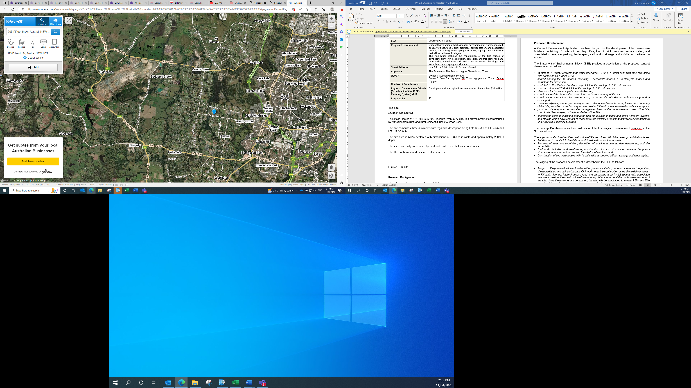
Figure 1: The site location shown with blue marker (Source: Whereis).

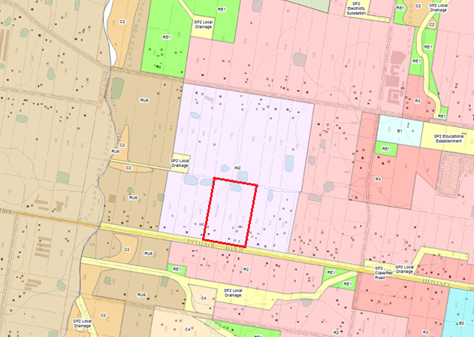Figure 2: Zoning map of the site and surrounds with site shown outlined red (Source: ePlanning Spatial Viewer).
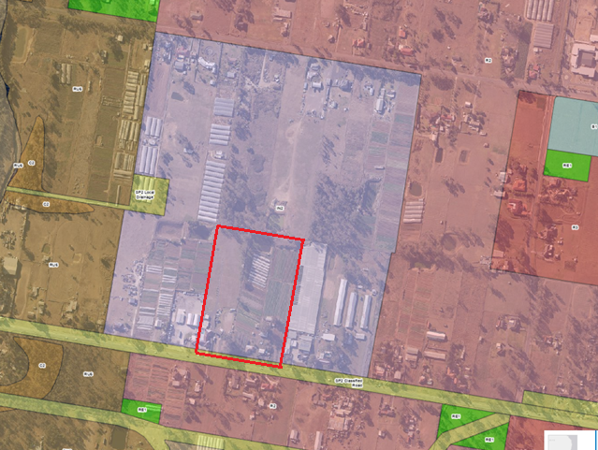Figure 3: Aerial photo of the site with zoning overlay and site shown outlined red (Source: ePlanning Spatial Viewer).

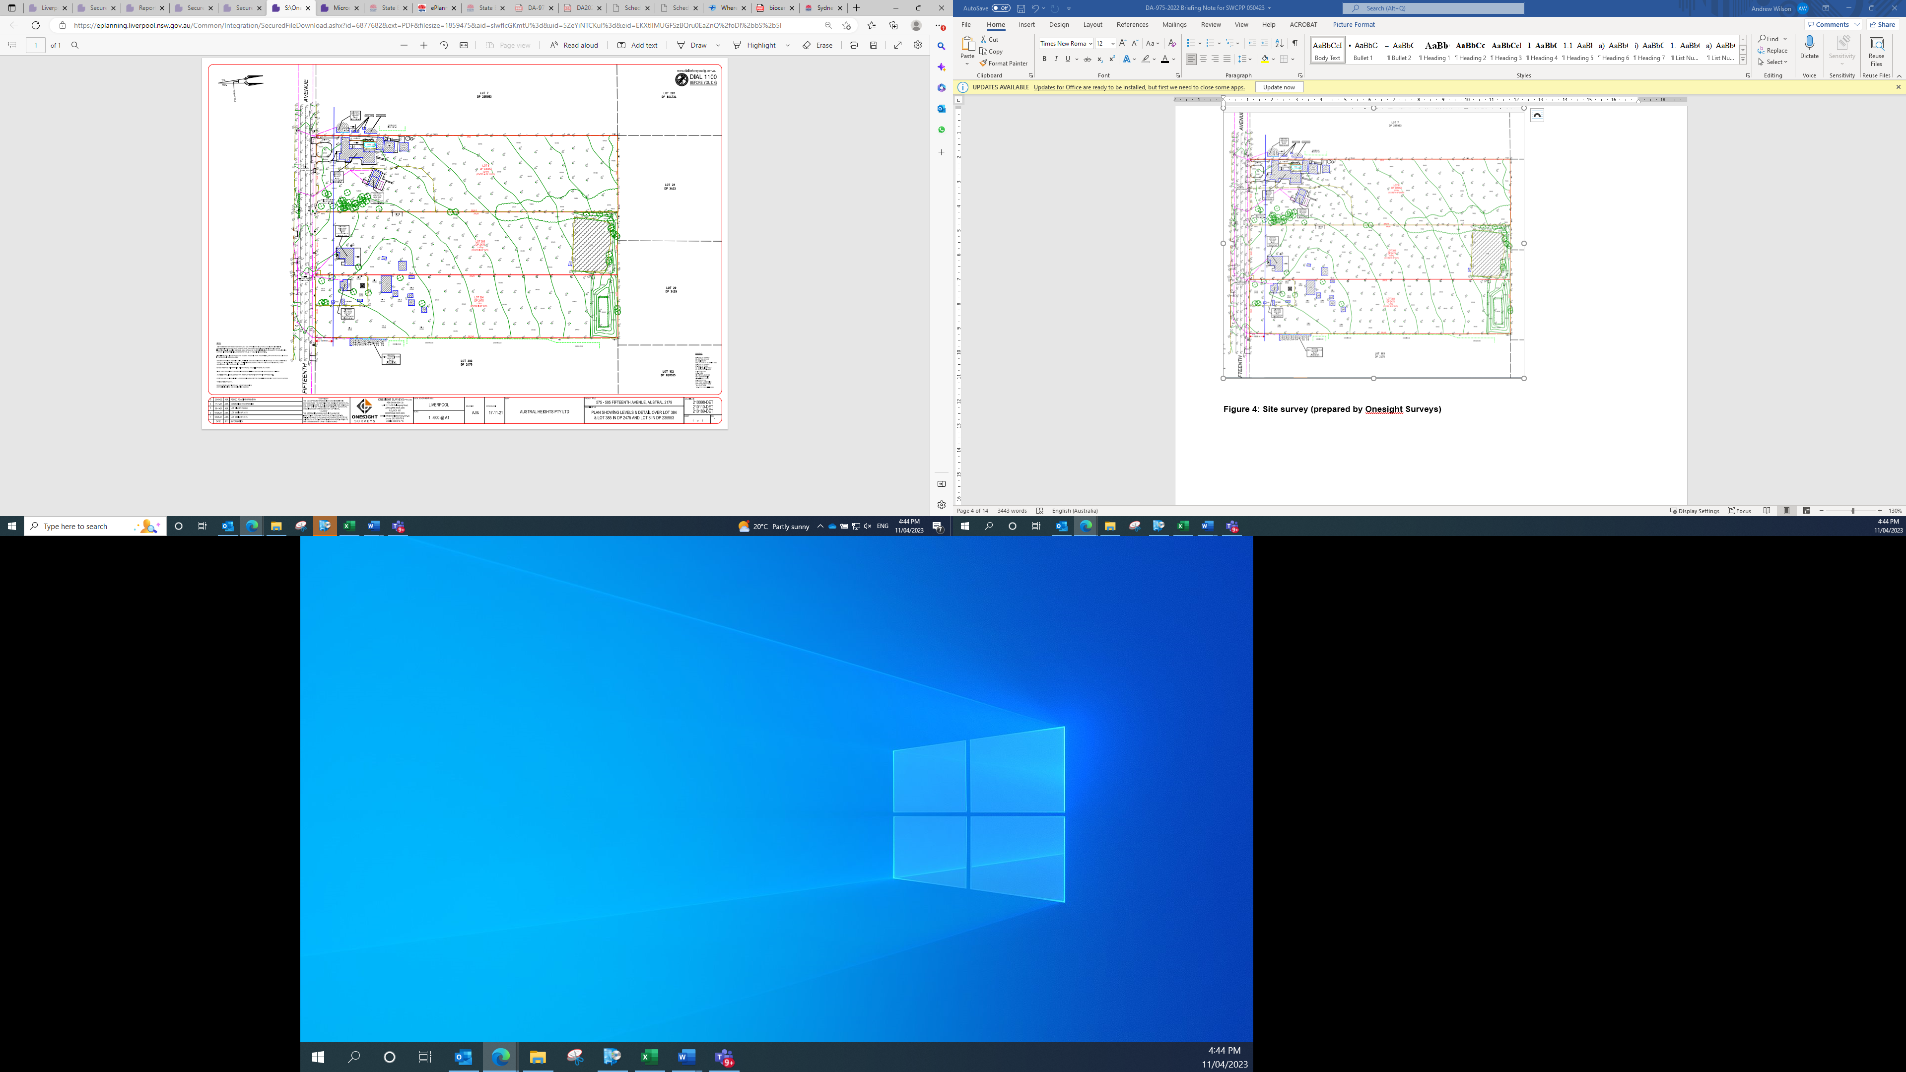
Figure 4: Site survey (prepared by Onesight Surveys)

- THE PROPOSAL AND BACKGROUND

  - Overview

A Concept Development Application has been lodged for the staged development of the following on the subject site:

- two warehouse buildings containing 13 units / tenancies and ancillary office space;
- food & drink premises buildings with 8 tenancies including 3 tenancies with drive-through;
- service station; and
- associated vehicle access, car parking, landscaping and fencing, signage, and civil works that includes stormwater management, earthworks, dam dewatering, demolition, tree removal, utility services connections and subdivision for future road widening and part road dedications.

The development application proposes the development to be undertaken in three (3) stages as follows:

Stage 1 – Site preparation including demolition, dam-dewatering, removal of trees and vegetation, site remediation and bulk earthworks. Civil works over the front portion of the site to deliver access to Fifteenth Avenue, internal access road and carparking area for 62 spaces with associated services as well as the construction of a temporary detention basin, including a temporary level spreader to discharge stormwater and temporary circulation road at the north-western corner of the site and a permanent on-site water quality treatment system. Construction of two warehouses with 11 units with associated offices, signage and landscaping. Once these works are completed, the land will be subdivided to create 1
Torrens Title industrial lots and 4 residue lots for future road dedications.

Stage 2 – Construction of 6 restaurant and entertainment premises, 3 food and drink premise, service station with 101 car parking spaces and associated landscaping. This stage development will be the subject of a future DA and be consistent with the Concept Plan.

Stage 3 - Decommissioning of detention basin and level spreader, including fill and construction for the remainder of warehouse 1 (units 1H and 1J). Stage 3 will commence once the regional basin infrastructure has been completed and the temporary detention basin is no longer required. The temporary level spreader will be replaced with a below ground tank with cartridge system to provide permanent on-site water quality treatment. Once the level spreader is decommissioned, the internal access road will be constructed through the site to the future local road along the northern boundary of the Site subject to Council confirmation. A condition of consent has been imposed to that effect.

Important Note: Following the completion of Stage 1 and registration of the industrial lots and residue lots, the Applicant will then be able to proceed with Stage 2 independently (or concurrently all together if they so choose). Stage 3 commencement is tied to Council’s delivery of the regional stormwater management basin to the west. Note that any development of Stage 2 will be subject to separate DA approval and will be required to be consistent with the Concept Plan.

Details of the proposed the development as staged is as follows:

3.2 Staging of Development
Staging of DAs
The staging of the DAs includes a Concept Plan DA which is the subject of this assessment and Future Stage Detailed DA/s.
The Concept Plan DA is for a concept plan for the whole development, and for the design and construction of the warehouse buildings and all the civil works, vehicle access and parking arrangements, landscaping, stormwater management, and utility services connections to these elements.
The Future Stage DA/s will be for the design and construction of the food and drink premises buildings, service station structures and associated landscaping and car parking.
Staging of Construction
The proposed development includes the staging of construction of buildings, driveways and stormwater management elements as described below:
Buildings, civil works and subdivision: The construction of the buildings, landscaping and civil works and the subdivision for road dedication are staged as follows:
- The first stage involves the construction of two warehouse buildings containing 11 units / tenancies and adjacent landscaping; civil works across the whole site including earthworks, access driveways, stormwater management, demolition, tree removal; utility services connections for the warehousing; and subdivision for road dedication.
- The second stage involves the construction of food and drink premises and service station.
- A third stage involves an extension to one of the warehouse buildings with an additional 2 units / tenancies (associated with the staging of stormwater works – see further below).
Access driveway off Fifteenth Avenue: The construction of a left-in/left-out driveway off Fifteenth Avenue on the southern boundary of the site is to be staged as follows:
- The first interim stage provides initial temporary left-in/left-out access for the whole site (until the future ILP public road is constructed and operating along the eastern boundary of the site for the main permanent access driveway for the site).
- The second stage provides the ultimate left-in/left-out access for the service station only (after the future ILP public road is constructed and in operation along the eastern boundary of the site connecting the main access driveway for the site).

Stormwater management: The construction of part of the stormwater management system on the site is to be staged as follows:
- The first stage involves a temporary on-site detention basin and level spreader on the north-west corner of the site (that also includes a temporary driveway around the spreader).
- The third stage of the development involves the removal of the temporary on-site detention basin and level spreader, construction of tank with water quality cartridges, and discharge from the site into a stormwater main in the future ILP road along the northern boundary which connects into the future precinct wide stormwater system. (This stage also involves extending one of the warehouse buildings with 2 additional units / tenancies over the area previously occupied by the temporary on-site detention basin, shifting a driveway over to the area previously occupied by the temporary level spreader, and re-landscaping the superseded driveway location).

3.3 Land uses
The proposed development includes the following land uses and gross floor areas:
Land uses | Gross Floor Area
Warehouse  ancillary office | 20,630sqm 2,705 sq.m
Food and drink premises | 2,105sqm
Service Station | 230sqm

3.4 Building Envelopes
The proposed concept plan includes the following building envelopes:
- Two (2) warehouse buildings containing thirteen 13 units including ancillary office space.
- Six (6) food and drink premises buildings containing 7 units / tenancies;
- One (1) service station building with 1 food and drink premises attached.

Building height
The proposed warehouse buildings are single storey an internal mezzanine level on corners of each unit / tenancy for ancillary office space. The warehouse building heights range from 10 metres to 16 metres above existing ground level.
The heights of the food & drink premises and service station are to be subject to future DA stage for their design and construction.
Setbacks
The development proposes the following developments off the site’s future boundary:
Boundary | Setback
North (future ILP road boundary) | 7m
South (widened Fifteenth Ave boundary | 10m to 44m
East (future ILP road boundary) | 7m to 14m
West (neighbouring property boundary) | 9.3m to 18.2m

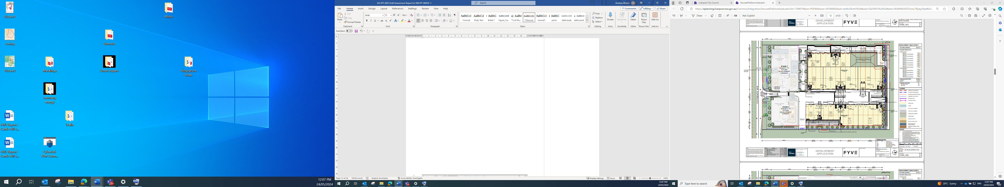
Figure 5 – Site layout of first stage of development that includes warehouse component with temporary access arrangement off Fifteenth Avenue and temporary on-site detention tank on northwest corner
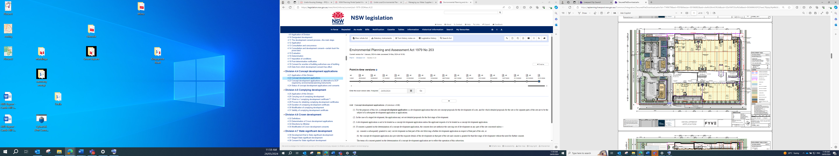
Figure 6 – Site layout of final stage of ultimate development
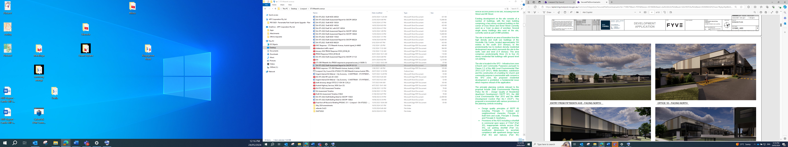

Figures 7 and 8 – CGI illustrations of the proposed development

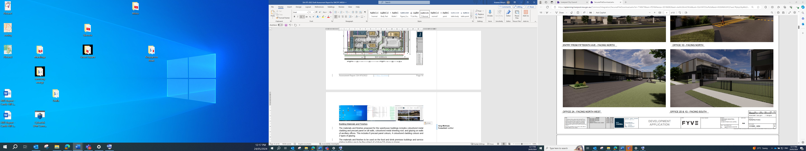

Figures 9 and 10 – CGI illustrations of the proposed warehouse buildings

Building Materials and Finishes
The materials and finishes proposed for the warehouse buildings includes colorbond metal cladding and precast panel on all walls, Colourbond metal sheeting roof, and glazing on walls of ancillary offices. This includes 6 precast panel colours, 4 colorbond cladding colours and 2 types of glazing.
The materials and finishes to be used on the food and drink premises buildings and service station building are to be the subject of a future DA stage or stages.
3.5. Vehicle Access and Parking
The proposed development involves a staging of vehicle access arrangements which is associated with the construction of future ILP roads around the site.
Ultimate Access
The application proposes the following access points upon the finalisation of all stages of this development:
- Primary vehicle driveway access to both warehouses will be provided off the future ILP road running along the eastern boundary of the site.
- Two (2) secondary driveways will be provided off the future ILP road running along the northern boundary of the site.
- A left in / left out driveway off Fifteenth Avenue will provide access for the service station and its attached food and drink premises.

Interim Access
A temporary left-in/left-out vehicle access driveway is provided off Fifteenth Avenue to serve the whole development site. This will operate in the interim until the future ILP public road along the eastern boundary of the site is operational for the primary vehicle access for the site.
Parking
The DA proposes the following parking provisions for all stages of the development:
Land use | Parking
Food and drink premises  (standalone premises) | 120
Service station and attached food and drink premises | 42
Warehouses | 101
Total | 265
An internal traffic management plan is submitted with the DA.
3.6 Landscaping and fencing
The proposed development includes landscape planting around the perimeter of the site, along a landscaped strip between the main warehouse area of the site and the area occupied by the proposed food & drink premises and service station, through car parking areas, and in the temporary on-site detention basin.

The landscaping includes large trees planted and retained along the Fifteenth Avenue frontage along the southern boundary, and large trees planted along the northern and eastern boundary setbacks that are to become the site frontages and streetscape along future ILP roads on theses boundaries.
The DA includes removal of 87 trees, and retention of 9 trees fronting Fifteenth Avenue.
Boundary fencing is proposed in the DA including black palisade fencing around the frontage to existing and future public roads on the northern, eastern and southern boundaries, and chain mesh security fencing along the western boundary.
3.7 Stormwater
The proposed development includes the following stormwater and drainage plans:
Reusable water
All roof water from eastern portion of warehouse units 2c and 2d to discharge directly to proposed rainwater tank to provide water for re-use on site.
Interim - water to be drained:
All water to be drained off site will be collected off roofs through downpipes or through ground drainage pits. This water will be drained into a temporary stormwater basin until precinct wide basin is developed.
All other water will drain to Gurner Avenue via a pipe constructed a property to the north using a northwest boundary drainage outlet.
Ultimate - water to be drained:
All water to be drained off site will be collected off roofs through downpipes or through ground drainage pits. This water will be drained to the precinct wide basin.
All other water will drain to newly constructed ILP road to the north using a northwest boundary drainage outlet.
3.8 Utilities Services Connections
The following utility infrastructure is proposed:
- Sewer – A new sewer main extension will be constructed to connect to the Kemps Creek Carrier.
- Water – An existing 100mm uPVC potable water main runs along the northern verge of Fifteenth Avenue.
- Electricity – A pad-mount substation within the development is required to service the development. New street lighting network will also be required within the new industrial street.
- Telecommunication – Existing telecommunication conduits are available within the surrounding street network.

3.9 Signage
The development proposes the following business identification signage:
- Two (2) x 6m high pylon signs will be situated along Fifteenth Avenue frontages. These signs will be for the warehouse business park and for service station.

- Three (3) x 4m high pylon signs will be situated along the future ILP road frontages. These signs will be used for the food and drink premises and warehouses.

- Fourteen (14) x wall signs for warehouse tenancies.

3.10 Lighting
The DA does not include any details of proposed lighting within the development. The applicant proposes to submit a lighting plan for Council approval after the granting of development consent and prior to the issue of a construction certificate.
3.11 Site Preparation Works
Demolition
Demolition of the existing dwelling houses and shed structures on site is included in the DA.
Tree Removal
A total of 87 trees are proposed for removal in the DA.
Earthworks
The DA includes earthworks with the volumes of cut and fill as follows:
- Cut: -41,153m³
- Fill: +12,802m³
- Balance: - 28,351m³.
Dam de-watering
De-watering of the dam on the central northern side of the site is included in the DA.
3.12 Subdivision
The proposed development includes the subdivision of the site to create separate lots for the following road dedications:
- Lot for the widening of Fifteenth Avenue along the southern boundary of the site;
- Lot for a part width of the future ILP road along the eastern boundary of the site;
- Lot for a part width of the future ILP road along the northern boundary of the site.

- STATUTORY CONSIDERATIONS

4.1 Concept Development Application – Section 4.22 of the EP&A Act

An assessment pursuant to Section 4.22 of the Environmental Planning and Assessment (EP & A) Act 1979 is provided below;

4.22 Concept development applications

- For the purposes of this Act, a concept development application is a development application that sets out concept proposals for the development of a site, and for which detailed proposals for the site or for separate parts of the site are to be the subject of a subsequent development application or applications.
- In the case of a staged development, the application may set out detailed proposals for the first stage of development.
- A development application is not to be treated as a concept development application unless the applicant requests it to be treated as a concept development application.

Comment: The subject application is lodged as a concept development application that sets out a concept proposal for the whole site, a detailed proposal for the carrying out of the first stage of development across parts of the site, and lodgement of subsequent development application/s for future detailed proposals across parts of the site.

(4) If consent is granted on the determination of a concept development application, the consent does not authorise the carrying out of development on any part of the site concerned unless:
(a) consent is subsequently granted to carry out development on that part of the site following a further development application in respect of that part of the site, or
(b) the concept development application also provided the requisite details of the development on that part of the site and consent is granted for that first stage of development without the need for further consent.

The terms of a consent granted on the determination of a concept development application are to reflect the operation of this subsection.

Comment: The recommended development consent includes condition terms reflecting the operation of subsection 4 above by specifying that consent is granted to a concept application and the carrying out of the first stage of development, and that future development application/s are required for the carrying out of the later stages of development.

(5) The consent authority, when considering under section 4.15 the likely impact of the development the subject of a concept development application, need only consider the likely impact of the concept proposals (and any first stage of development included in the application) and does not need to consider the likely impact of the carrying out of development that may be the subject of subsequent development applications

Comment: An assessment of the likely impacts of the concept proposal and first stage of development to the extent it is deemed appropriate against section 4.15 is provided below.

4.2 Matters for Consideration – Section 4.15(1) of the EP&A Act

When determining a development application, the consent authority must take into consideration the matters outlined in Section 4.15(1) of the Environmental Planning and Assessment Act 1979 (‘EP&A Act’). These matters as are of relevance to the development application include the following:

- the provisions of any environmental planning instrument, proposed instrument, development control plan, planning agreement and the regulations
(i) any environmental planning instrument, and
(ii) any proposed instrument that is or has been the subject of public consultation under this Act and that has been notified to the consent authority (unless the Planning Secretary has notified the consent authority that the making of the proposed instrument has been deferred indefinitely or has not been approved), and
(iii) any development control plan, and
(iiia) any planning agreement that has been entered into under section 7.4, or any draft planning agreement that a developer has offered to enter into under section 7.4, and
(iv) the regulations (to the extent that they prescribe matters for the purposes of this paragraph),
that apply to the land to which the development application relates,
- the likely impacts of that development, including environmental impacts on both the natural and built environments, and social and economic impacts in the locality,
- the suitability of the site for the development,
- any submissions made in accordance with this Act or the regulations,
- the public interest.

These matters are further considered below.

  - Section 4.15(1)(a)(i) - Environmental Planning Instruments

The following Environmental Planning Instruments are relevant to this application:

- State Environmental Planning Policy (Planning Systems) 2021
- State Environmental Planning Policy (Precincts—Western Parkland City) 2021
- State Environmental Planning Policy (Transport and Infrastructure) 2021
- State Environmental Planning Policy (Biodiversity and Conservation) 2021
- State Environmental Planning Policy (Resilience and Hazards) 2021
- State Environmental Planning Policy (Industry and Employment) 2021

A summary of the key matters for consideration arising from these State Environmental Planning Policies are outlined in the following table and considered in more detail further below.
Table 1: Summary of Applicable Environmental Planning Instruments
EPI | Matters for Consideration | Comply (Y/N)
State Environmental Planning Policy (Planning Systems) 2021 | Chapter 2: State and Regional Development  - Section 2.19(1) declares the proposal regionally significant development pursuant to Item 2 of Schedule 6 as the development has a capital investment value of more than $30 million. | Yes
State Environmental Planning Policy (Precincts—Western Parkland City) 2021 | Chapter 3 Sydney Region Growth Centres and Appendix 4 Liverpool Growth Centres Precinct Plan  - IN2 Light Industrial Zone – Development is permissible with consent and consistent with zone objectives.  - Building height limit of 13m – Parts of the proposed warehouse buildings exceed the height limit, and the DA relies on a clause 4.6 exception to the height standard which is justified.  - Maximum Floor Space Ratio of 1:1 – Development complies with FSR of 0.44:1. | Yes (with clause 4.6 exception to height)
State Environmental Planning Policy (Transport and Infrastructure) 2021 | Chapter 2: Infrastructure  - Section 2.118(2) - Development with frontage to classified road  - Section 2.119(2) Impact of road noise or vibration on non-road development  - Section 2.121(4) – Traffic Generating Development  - The DA is supported by Transport for NSW and Council traffic engineers. | Yes
State Environmental Planning Policy (Biodiversity & Conservation) 2021 | Chapter 2: Vegetation in non-rural areas  Chapter 9: Hawkesbury-Nepean River | Yes, with conditions
SEPP (Resilience & Hazards) | Chapter 4: Remediation of Land  - Section 4.6 - A Contamination Report is submitted with the DA which finds the site suitable.  Chapter 3: Hazardous and offensive development  - Section 3.11 - A preliminary hazard analysis will be required as part of a future DA stage for the design and construction of the service station. | Yes
State Environmental Planning Policy (Industry and Employment) 2021 | Chapter 3: Advertising and Signage  - Section 3.6 – granting consent to signage  - Section 3.11(1) – signage matters for consideration | Yes
Proposed Instruments | None applicable. | N/A

- State Environmental Planning Policy (Planning Systems) 2021 - Chapter 2: State and Regional Development
Section 2.19(1) and associated Schedule 6 in the SEPP (Planning Systems) 2021 declare development with a capital investment value (CIV) of more than $30 million as regionally significant development.
The proposed development has a CIV of over $41 million and is therefore regionally significant development for which the Sydney Western City Planning Panel is the consent authority.
- State Environmental Planning Policy (Precincts – Western Parkland City) 2021 - Appendix 4 (Liverpool Growth Centres Precinct Plan)

The SEPP (Precincts – Western Parkland City) 2021 and its Appendix 4 (Liverpool Growth Centres Precinct Plan) is the principal planning instrument applying to the site. The aims of the Liverpool Growth Centres Precinct Plan are as follows—
(a) to make development controls that will ensure the creation of quality environments and good design outcomes,
(b) to protect and enhance environmentally sensitive natural areas and cultural heritage,
(c) to provide for recreational opportunities,
(d) to provide for multifunctional and innovative development that encourages employment and economic growth,
(e) to promote housing choice and affordability,
(f) to provide for sustainable development,
(g) to promote pedestrian and vehicle connectivity.
The proposal is consistent with these aims as the proposal is a good design outcome with a quality environment, has appropriate environmental protection and sustainability measures, provides for recreational use of workers, generates employment and economic activity in warehousing, hospitality and vehicle servicing, and includes suitable vehicle and pedestrian access connections and management.

- Zoning

The site is zoned IN2 Light Industrial with a thin strip along the Fifteenth Avenue frontage zoned SP2 Infrastructure - Classified Road under Clause 2.2 and the zoning map under the SEPP (Precincts - Western Parkland City) 2021 - Appendix 4 (Liverpool Growth Centres Precinct Plan).

- Permissibility

The proposed land uses fall within the SEPP definitions of warehouse, food & drink premises, and service station which are all permissible with consent in the IN2 Zone.

- Objectives of the zone
The proposed development is consistent with the objectives of the zone as described below.

IN2 Zone Objectives | Proposed Development | Consistent
To provide a wide range of light industrial, warehouse and related land uses. | The proposed land uses are warehouses, food & drink premises, and service station. Warehousing is the proposed predominant use comprising 95% of the total gross leasable floor area in the development.  The food & drink premises and service station will cater for workers in industry and warehouse planned for the locality. | Yes
To encourage employment opportunities and to support the viability of centres. | The proposed food & drink premises are aimed at catering to passing traffic on Fifteenth Avenue to and from the Aerotropolis and surrounding employment zones and residential areas.  The proposed food & drink premises will not impact on the viability of existing and planned future centres in the locality as explained in the Economic Impact Assessment in the DA. | Yes
To minimise any adverse effect of industry on other land uses. | No industrial use is proposed in the DA. The proposed warehouse, food & drink premises and service station uses and development design are compatible with the existing rural uses and future industrial zone uses on surrounding properties to the north, west and east.  The impact of the proposed development on the residential zone properties to the south on the opposite side of the Fifteenth Avenue main road corridor is minimised and not unreasonable as described below in Sections 3.2 and 5.6 of this report. | Yes
To enable other land uses that provide facilities or services to meet the day to day needs of workers in the area. | The proposed food & drink premises and service station will provide for the day to day needs of workers in the area. This includes future workers in the proposed development and in future development in the industrial zone in which the site is located, and also workers travelling along the Fifteenth Avenue Road corridor to and from the Aerotropolis and other nearby employment areas. | Yes

Figure 11 - Zoning Map
- Principal Development Standards and Provisions

An assessment of the proposed development against the relevant principal development standards and provisions in the Western Parkland City SEPP - Appendix 4 (Liverpool Growth Centres Precinct Plan) is provided in the following table of compliance.

Provision | Proposed Development | Comply
Clause 4.3 - Height of buildings  (13m building height limit) | A building height limit of 13m applies to the site.  The proposed development partly complies and partly exceeds the 13m height limit.  The southern parts of the warehouse buildings comply with the 13m height limit, as will the food & drink premises and service station.  The northern part of each warehouse building exceeds the 13m height limit reaching up to heights of approximately 16m on the northern end of the Warehouse 1 building and approximately 14.5m on the northern end of the Warehouse 2 building.  A Clause 4.6 exception report has been submitted by the applicant justifying the exceedance of the building height standard. The proposed height exceedance is considered justified in the circumstances as explained below in the commentary under clause 4.6. | Part Yes  Part No
Clause 4.4 - Floor Space Ratio  (Maximum 1:1 FSR) | A maximum floor space ratio of 1:1 applies to the site.  The proposed development has an FSR of 0.44:1 and complies with the FSR standard. | Yes
Clause 4.6 - Exception to development standards | A Clause 4.6 Variation to Height of Buildings Development Standard report has been submitted with the DA to justify the contravention of the height of buildings standard mentioned above and is included at Attachment C. (Refer to a detailed assessment of the Clause 4.6 report further below). | Yes
Clause 5.9 - Preservation of trees or vegetation | The DA proposes removal of trees and complies with clause 5.9 insofar as the clause requires DA consent for removal of trees.  The proposed tree removal however is not consistent with the objective of clause 5.9 “to preserve the amenity of the area through the preservation of trees and other vegetation” as it includes removal of trees along the southern side of the site which provide amenity, landscape/streetscape, and microclimate value where there is minimal earthworks and ample opportunity for tree retention. This includes 19 trees identified in the arborist report submitted with the DA as having moderate to high landscape significance and retention value.  The applicant was requested to submit amended plans retaining trees along the southern side of the site which provide amenity, landscape/streetscape, and microclimate value.  The amended plans retain 9 trees along the southern boundary of the site. However, 6 of the 9 trees are in the area identified for future widening of Fifteenth Avenue and likely to be removed with the widening, leaving 3 trees on the site which is not satisfactory.  A condition of consent is recommended requiring the retention of at least 4 trees on the southern part of the site which are identified in the arborist report submitted with the DA as having moderate to high landscape significance and retention value and are located outside the area identified for widening of Fifteenth Avenue. | Yes
Clause 5.10 - Heritage conservation | There are no heritage items on or surrounding the site.  An Aboriginal Due Diligence Assessment Report prepared by OzArk Environment & Heritage is submitted with the DA which finds no known Aboriginal sites or landforms with identified archaeological sensitivity are present within the study area, and there is a low potential for Aboriginal objects to be harmed within the study area. | Yes
Clause 6.1 - Public Utility Infrastructure | Utility services are available in the area to service the proposed development as described in the SEE and supporting documentation. | Yes

The proposal is considered to be in compliance with the Western Parkland City SEPP - Appendix 4 (Liverpool Growth Centres Precinct Plan).

- Clause 4.6 Exception to Height Standard

(Note: Clause 4.6 in Appendix 4 of the SEPP (Precincts - Western Parkland City) 2021 was amended on 15 December 2023. The savings provision in section 3.9(3) of the SEPP states that a DA made but not determined before the commencement of the amendment, which includes this subject DA-975/2022, must be determined as if the amendment had not commenced.)

A Clause 4.6 Variation to Height of Buildings Development Standard report has been submitted with the DA to justify the contravention of the height of buildings standard mentioned above and is included at Attachment C.

Clause 4.6 of the Western Parkland City SEPP - Appendix 4 (Liverpool Growth Centres Precinct Plan) enables the consent authority in subclause (2) to grant consent to development which contravenes a development standard, subject to being satisfied of the preconditions in subclause (3). Clause 4.6(2) and (3) are quoted below:

(2) Development consent may, subject to this section, be granted for development even though the development would contravene a development standard imposed by this or any other environmental planning instrument.
(3) Development consent must not be granted to development that contravenes a development standard unless the consent authority is satisfied the applicant for development consent has demonstrated that—
(a) compliance with the development standard is unreasonable or unnecessary in the circumstances, and
(b) there are sufficient environmental planning grounds to justify the contravention of the development standard.

The Development Standard to be varied and extent of the variation
The development standard to which the Clause 4.6 variation request applies is the 13m building height standard in clause 4.3 of the Western Parkland City SEPP Appendix 4 Appendix 4 (Liverpool Growth Centres Precinct Plan).
The warehouse buildings in the proposed development are partly lower and partly higher than the 13m height limit. The northern part of each warehouse building exceeds the 13m height limit reaching up to heights of 16m on the northern end of the Warehouse 1 building and approximately 14.8m on the northern end of the Warehouse 2 building. The variation to the height standard ranges from nil (i.e. lower than the maximum) and up to 3m which represents a variation of between 0% to 23% to the maximum 13m building height applying to the site.

The extent of the height exceedance is illustrated in the height plane diagram prepared by the applicant’s architect below.

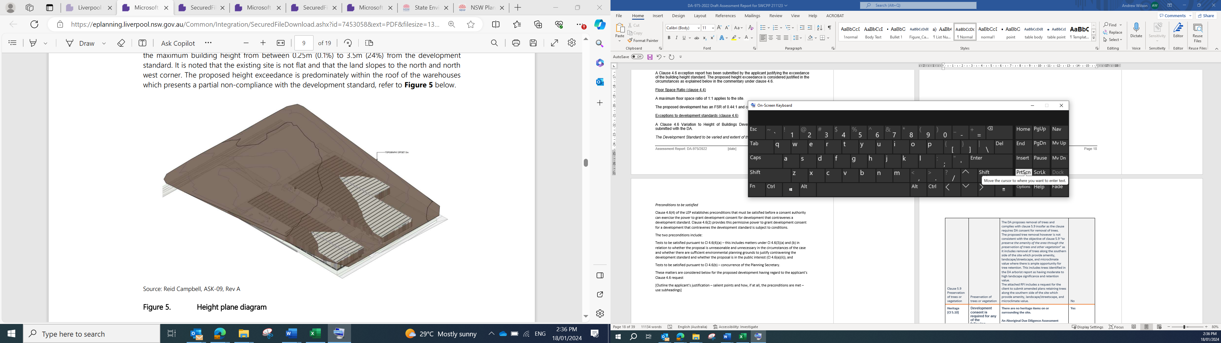

Preconditions to be satisfied in Clause 4.6(3)
Clause 4.6(3) establishes preconditions that must be satisfied before a consent authority can exercise the power to grant development consent for development that contravenes a development standard. The preconditions in Clause 4.6(3) are addressed below.
Precondition 1: The applicant has demonstrated the matters in Clauses 3(a) and (b).
The applicant has submitted a Clause 4.6 Variation to Height of Buildings Development Standard report which satisfactorily demonstrates the matters in Clauses 3(a) and (b).
Precondition 2: Compliance with the development standard is unreasonable or unnecessary in the circumstances.
The applicant’s Clause 4.6 Variation report refers to the established precedents of the Land and Environment Court as follows:
In Wehbe v Pittwater Council (2007) NSWLEC 827, Preston CJ established five potential ways for determining whether a development standard could be considered to be unreasonable or unnecessary. These include:
1. The objectives of the standard are achieved notwithstanding non-compliance with the standard;
2. The underlying objective or purpose of the standard is not relevant to the development and therefore compliance is unnecessary;
3. The underlying object or purpose would be defeated or thwarted if compliance was required and therefore compliance is unreasonable;
4. The development standard has been virtually abandoned or destroyed by the Council’s own actions in granting consents departing from the standard and hence compliance with the standard is unnecessary and unreasonable.
5. The zoning of the particular land is unreasonable or inappropriate so that a development standard appropriate for that zoning is also unreasonable and unnecessary as it applies to the land and compliance with the standard would be unreasonable or unnecessary. That is, the particular parcel of land should not have been included in the particular zone.
We note that whilst Wehbe was a decision of the Court dealing with SEPP 1, it has been also found to be applicable in the consideration and assessment of Clause 4.6. Regard is also had to the Court’s decision in Four2Five Pty Limited v Ashfield Council [2015] NSWLEC 90 and Randwick City Council v Micaul Holdings Pty Ltd [2016] NSWLEC 7, which elaborated on how these five ways ought to be applied, requiring justification beyond compliance with the objectives of the development standard and the zone. In addition to the above, Preston CJ further clarified the appropriate tests for a consideration of a request to vary a development standard in accordance with clause 4.6 in Initial Action Pty Ltd v Woollahra Municipal Council [2018] NSWLEC 118. This decision clarifies a number of matters including that:
• the five ways to be satisfied about whether to invoke clause 4.6 as outlined in Wehbe are not exhaustive (merely the most commonly invoked ways);
• it may be sufficient to establish only one way;
• the written request must be “sufficient” to justify contravening the development standard; and
• it is not necessary for a non-compliant development to have a neutral or beneficial effect relative to a compliant development.
The applicant’s Clause 4.6 Variation report demonstrates the first and second points above in the Wehbe case precedent are satisfied in considering whether compliance with the height standard is unreasonable or unnecessary relative to the objectives of the building height standard as described in the table below.

Objectives of the Building Height Standard | Clause 4.6 Variation Report
Objective (a) - to establish the maximum height of buildings | The objective of the standard is not relevant to the development.
Objective (b) - to minimise visual impact and protect the amenity of adjoining development and land in terms of solar access to buildings and open space | The applicant has submitted a Visual Impact Assessment demonstrating that the exceedance of the height limit will have a minimal impact on the visual landscape as illustrated in the images extracted from it following this table below.  The proposed development and in particular the height exceedance will not have any significant impact on the amenity of adjoining development in terms of solar access and open space.  On land adjoining to the north, west and east, existing dwellings are located at respective distances of 315m, 150m and 150m away from the respective site boundaries and will not be affected by the height exceedance. These properties are also zoned IN2 Light Industrial and likely to take a form of uses in the future that do not generate a need for specific solar access at ground level or any public open space located in close proximity to the site. The proposed warehouse buildings have substantial boundary setbacks of 16m to northern boundary, 7m to eastern boundary and 18m to western boundary. Adjoining land to the north and east will also be further separated from the site with a future ILP road.  For land adjoining to the south, which is zoned residential, the development will not have any shadow impact on the residential zone to the south on the opposite side of Fifteenth Avenue and noting the southern side of the development complies with the height limit.
Objective (c) - to facilitate higher density development in and around commercial centres and major transport routes | The Site is located adjoining the major transport route of Fifteenth Avenue. Lowering the building height to comply with the height standard would impact the functionality and efficiency of the warehouse, and future tenants’ parts of the warehouse building would have substandard internal clearances that would not cater for typical tenant demands and likely reduce the overall employment density generated from the Site.

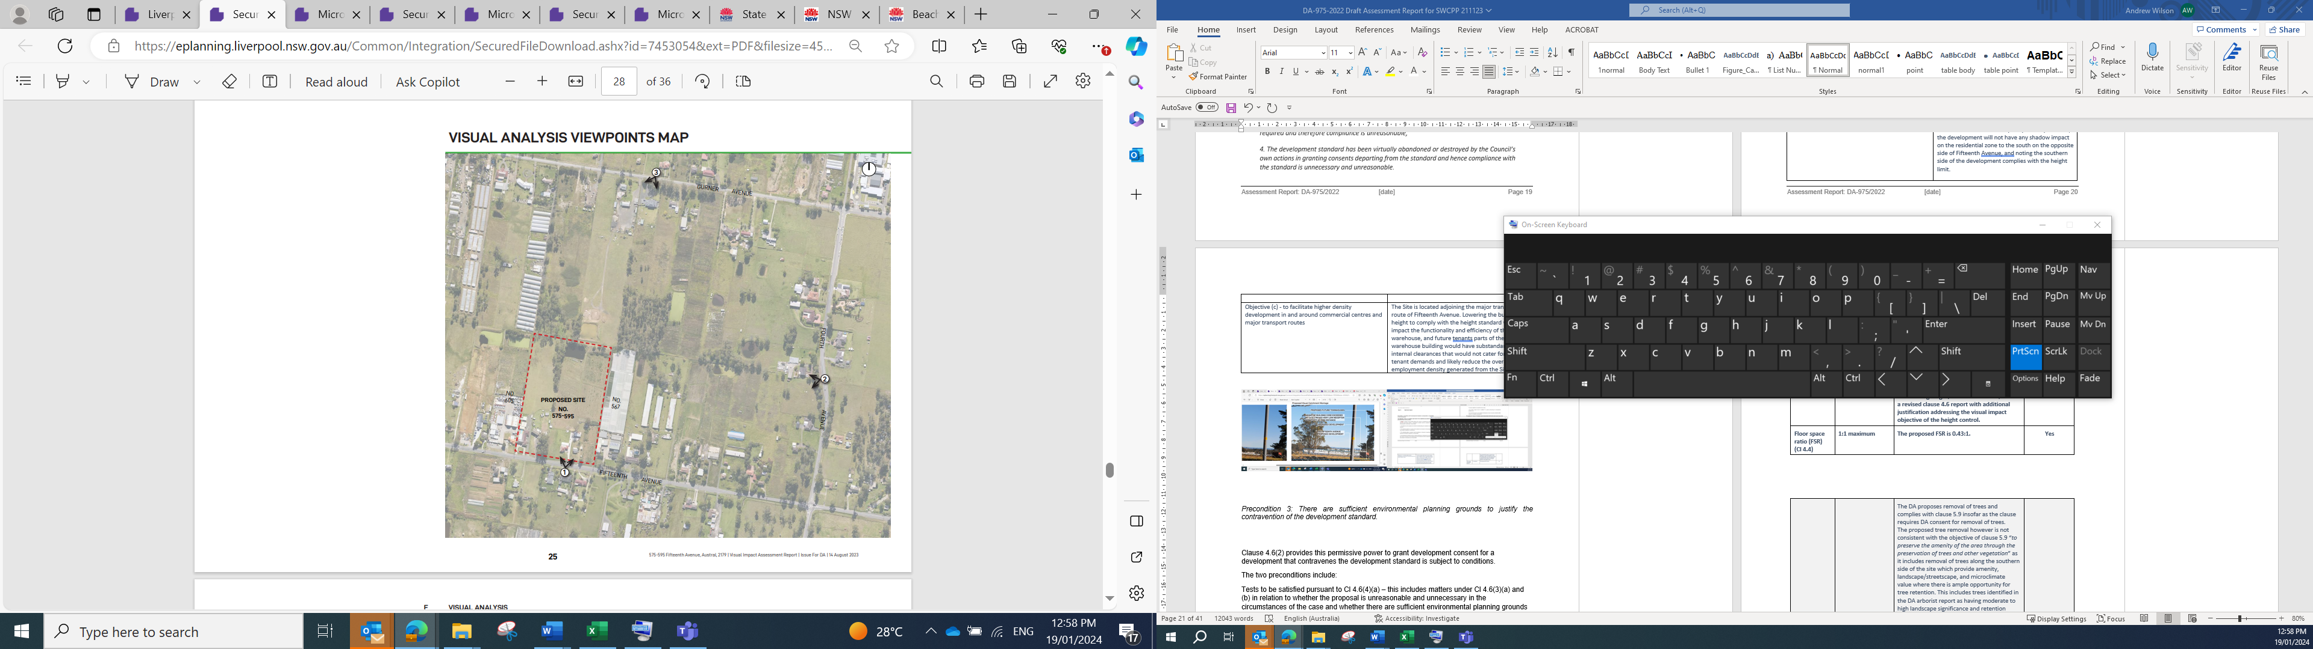
Figure 12 - Visual Analysis Viewpoints Map

Viewpoint 1
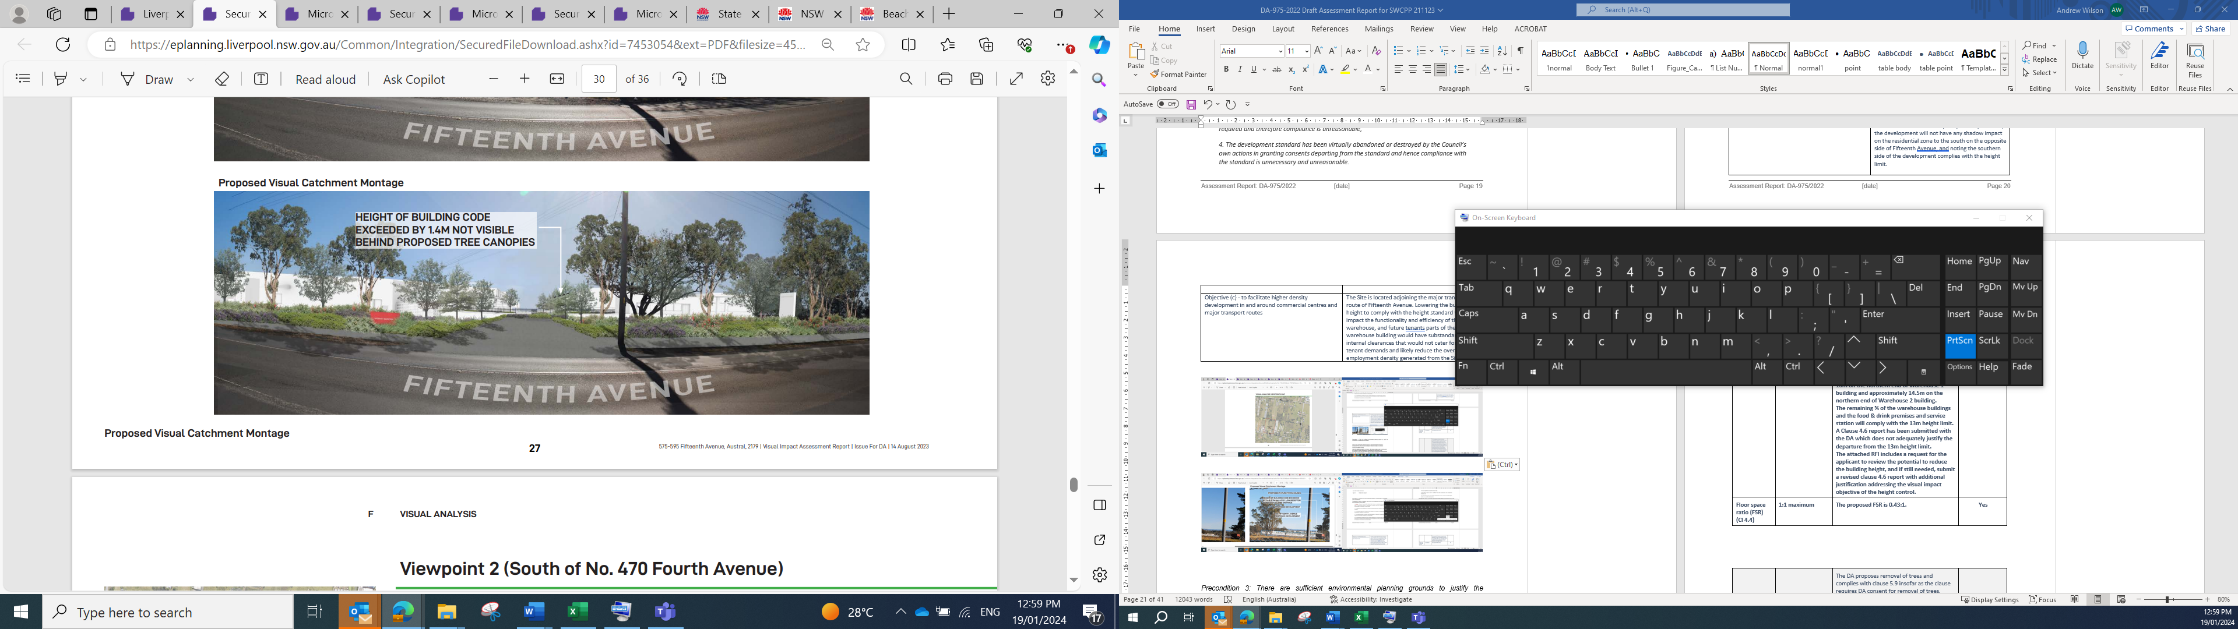

Viewpoint 2
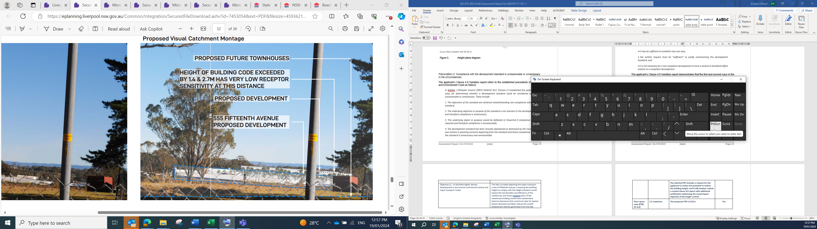

Viewpoint 3
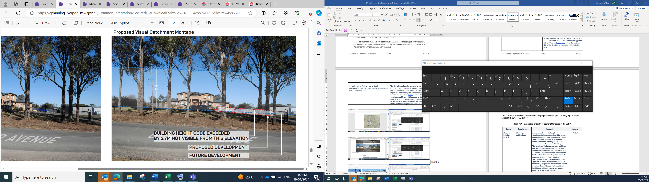

Precondition 3: There are sufficient environmental planning grounds to justify the contravention of the development standard.

The applicant’s Clause 4.6 Variation report identifies the environmental planning grounds for exceeding the 13m height standard which are summarised in the following points:
- The IN2 zoning has a blanket 13m height limit above existing ground level across the site.
- The existing ground level across the site has a cross fall of 8.2m from the highpoint at RL 67.5 near the centre of the southern part of the site to the low point at RL 59.3 on the north west corner. Consequently, the 13m height limit also has a crossfall of 8.2m across the site.
- Warehouse developments require floor plates that are generally flat and cover a large area and require building heights of at least 13m comprising 11m internal clearance and 2m for grading of roof lines.
- The design of the warehouse buildings across this sloping site has included efforts to transition / step the building levels across the site topography / cross fall. The ability to completely transition the levels with the slope topography is restricted by abovementioned requirements for viable warehouse development, and the need to have balance in earthworks cut & fill and meet design standards & grades for the stormwater management system and the vehicle loading & manoeuvring areas around the warehouse buildings.

Conclusion
The applicant’s Clause 4.6 Variation report has demonstrated that compliance with the 13m height standard is unreasonable and unnecessary in the circumstances, and there are sufficient environmental planning grounds to justify the contravention of the height standard pursuant to clause 4.6(3) of the Western Parkland City SEPP - Appendix 4 (Liverpool Growth Centres Precinct Plan). Development consent may therefore be granted to the proposed development pursuant to clause 4.6(2) of the SEPP even though it contravenes the height standard.

- State Environmental Planning Policy (Transport and Infrastructure) 2021

Part 2.3 Development controls – Division 17 Roads and traffic – Subdivision 2 Development in or adjacent to road corridors and road reservations

Clause 2.118 – Development on classified road

Clause 2.118 states that the concurrence of Transport for NSW (TfNSW) is to be sought for development with a cost of greater than $185,000 on land reserved for the purposes of a classified road (but before the land is declared to be a classified road) as quoted below.

2.118 Development on proposed classified road
(1) Consent for development for any of the following purposes on land reserved for the purposes of a classified road (but before the land is declared to be a classified road) may be granted only with the concurrence of TfNSW—
(a) ……….
(b) development with a capital investment value greater than $185,000,
(c) …...
(2) Before determining a development application (or an application for modification of a consent) for development to which this section applies, the consent authority must—
(a) give written notice of the application to TfNSW within 7 days after the application is made, and
(b) take into consideration any response to the notice that is received within 21 days after the notice is given.
Consideration has been given to whether clause 2.118 applies to the part of the site zoned SP2 reserved for the widening of Fifteenth Avenue which is understood to be the subject of plans to become a classified road in the near future.

TfNSW has been consulted on a number of occasions by both Council and the applicant.

- TfNSW will only support a driveway off Fifteenth Avenue providing for left turn in and left turn out vehicle movements and does not support the driveway providing right turn in and/or right turn out vehicle movements.
- The driveway off Fifteenth Avenue may be used in the interim for all approved uses operating on the site until the future ILP public road is constructed and operating along the eastern boundary of the site.
- After the future ILP public road is constructed and in operation along the eastern boundary of the site, the use of the driveway off Fifteenth Avenue is to be modified and limited to provide left-in/left-out vehicle access for the service station and its attached food & drink premises only, and the ultimate driveway access for the remainder of the warehouse uses and food & drink premises across the site is to be off the future ILP roads along the eastern and northern boundaries of the site.
- The ultimate driveway off the future ILP road along the eastern boundary of the site is to be located as far from the intersection with Fifteenth Avenue as possible.

The applicant has amended the DA plans in accordance with the comments in the TfNSW submissions and consultations. Conditions of consent are also recommended in the draft notice of determination restricting the access off Fifteenth Avenue as advised by TfNSW.

TfNSW’s latest submission dated 29 January 2024 is supportive of the DA and makes the following comments:
- The subject site is within an area under investigation for the proposed Fifteenth Avenue upgrade to support the new Western Sydney International Airport and Aerotropolis Precinct.
- At this point of time, TfNSW concurrence powers under s2.118 are not applicable as Fifteenth Avenue is not a considered a proposed classified road under Environmental Planning and Assessment Act 1979 currently. As such, TfNSW responses remain advisory pursuant to State Environmental Planning Policy (Transport and Infrastructure) 2021 clause 2.122 as the development is classified an ‘traffic generating development’.
- TfNSW is satisfied with the DA’s proposed setback to support the future upgrades of the corridor.
- TfNSW advises that the DA’s proposed ultimate vehicle access should consider access via Fifteenth Avenue only for the service station component of the development, with other land uses being restricted to vehicle access via the interim layout plan (ILP) road network.
The final TfNSW submission dated 29 January 2024 also advises of four conditions of consent to be imposed. These conditions require all buildings, structures and improvements being wholly within the freehold property, the developer to be responsible for utilities adjustments, the layout of car parking to comply with relevant Australian standards, and a Road Occupancy Licence to be obtained for any works impacting traffic flow on Fifteenth Avenue. These conditions are included in the draft notice of determination.

2.119 Development with frontage to classified road

Clause 2.119 of the SEPP (Transport and Infrastructure) 2021 states the consent authority must not grant consent to development on land with a frontage to a classified road unless it is satisfied of the particular matters quoted in the table below. In this case, clause 2.119 applies as the proposed development has frontage to the classified road Fifteenth Avenue.

Clause 2.119(2) | Assessment of DA
2) The consent authority must not grant consent to development on land that has a frontage to a classified road unless it is satisfied that—
(a) where practicable and safe, vehicular access to the land is provided by a road other than the classified road, and | The DA provides for the ultimate vehicle access off the future collector roads identified in the ILP rather than off the future classified road Fifteenth Ave. The exception is the proposed service station for which TfNSW, and Council traffic engineers agree to the ultimate access being left-in left-out off Fifteenth Ave.  In the short term interim, left-in / left-out access is proposed off Fifteenth Avenue for all the proposed uses which is supported by TfNSW and Council engineers.
(b) the safety, efficiency and ongoing operation of the classified road will not be adversely affected by the development as a result of— | TfNSW and Council traffic engineers are supportive of the vehicle access and traffic management arrangements in the amended design plans.
(i) the design of the vehicular access to the land, or | TfNSW and Council engineers are supportive of the design of the vehicular access to the land.
(ii) the emission of smoke or dust from the development, or | There is no significant emission of smoke or dust from the proposed land uses.
(iii) the nature, volume or frequency of vehicles using the classified road to gain access to the land, and | TfNSW and Council traffic engineers have raised no issue with the nature, volume and frequency of vehicles that would access the proposed land uses, subject to meeting their requirements on the design of the vehicle access which has been addressed in amended plans and traffic reports.
(c) the development is of a type that is not sensitive to traffic noise or vehicle emissions, or is appropriately located and designed, or includes measures, to ameliorate potential traffic noise or vehicle emissions within the site of the development arising from the adjacent classified road. | The proposed warehouse use, food and drink premises and service station are not particularly sensitive to noise or vehicle emissions from traffic on the adjacent Fifteenth Avenue future classified road.  The food & drink premises which could be sensitive are to be subject to future DAs for specific uses which will need to address this clause on traffic noise and vehicle emissions in the T&I SEPP.

Clause 2.122 – Traffic generating development.

Clause 2.122 of the T&I SEPP applies to traffic generating development identified in Schedule 3 of the SEPP. Each of the proposed land uses (warehouses, food and drink premises, and service station) is within a category of traffic generating development in the SEPP and subject to the provisions in subclause 4 below.

Clause 2.122(4) | Assessment of DA
(4) Before determining a development application for development to which this section applies, the consent authority must—
(a) give written notice of the application to TfNSW within 7 days after the application is made, and | Written notice has been provided to TfNSW.
(b) take into consideration—
(i) any submission that RMS provides in response to that notice within 21 days after the notice was given (unless, before the 21 days have passed, TfNSW advises that it will not be making a submission), and | The issues raised in TfNSW’s submissions on the DA have been satisfactorily addressed in amended DA plans.
(ii) the accessibility of the site concerned, including—
(A) the efficiency of movement of people and freight to and from the site and the extent of multi-purpose trips, and | The proposed development facilities efficient movement of people and freight to the extent it is located on a main road corridor to and from the Aerotropolis with the ultimate vehicle access being directly off the future adjoining ILP local roads.  The DA would facilitate multi-purpose trips to the extent that it may facilitate one trip for the multiple uses proposed on the site.
(B) the potential to minimise the need for travel by car and to maximise movement of freight in containers or bulk freight by rail, and | At present, there is no potential for users of the proposed development to minimise travel by car due to the site location in a developing growth area that is still on the outskirts of the existing urban area. In the future, there is potential for Fifteenth Avenue to become a bus route given it is a major east-west road corridor to and from the Aerotropolis, in which case there would be potential to minimise car travel for site users.  There is no potential in the DA to affect movement of freight by rail.
(iii) any potential traffic safety, road congestion or parking implications of the development. | TfNSW and Council engineers are satisfied with the road traffic and parking implications of the development.

The DA satisfactorily addresses the T&I SEPP provisions for traffic generating development with frontage to a future classified road.

- State Environmental Planning Policy (Biodiversity and Conservation) 2021

Chapter 2: Vegetation in non-rural areas
Chapter 2 of SEPP (Biodiversity and Conservation) 2021 requires DA consent for removal of trees.
The DA proposes the removal of trees and complies with Chapter 2 of the SEPP insofar as it seeks consent for the tree removal.
The proposed tree removal however is not considered consistent with the aims of the Chapter “(a) to protect the biodiversity values of trees and other vegetation in non-rural areas of the State, and (b) to preserve the amenity of non-rural areas of the State through the preservation of trees and other vegetation” as it includes removal of trees along the southern side of the site which provide amenity, landscape/streetscape, and microclimate value where there is minimal earthworks and ample opportunity for tree retention. This includes 19 trees identified in the arborist report submitted with the DA as having moderate to high landscape significance and retention value.

The applicant was requested to submit amended plans retaining trees along the southern side of the site which provide amenity, landscape/streetscape, and microclimate value.
The amended plans retain 9 trees along the southern boundary of the site. However, 6 of the 9 trees are in the area identified for future widening of Fifteenth Avenue and likely to be removed with the widening, leaving 3 trees on the site which is not satisfactory.
A condition of consent is recommended requiring the retention of at least 4 trees on the southern part of the site which are identified in the arborist report submitted with the DA as having moderate to high landscape significance and retention value and are located outside the area identified for widening of Fifteenth Avenue.

Chapter 9: Hawkesbury-Nepean River
(Note: Chapter 9 of the SEPP (Biodiversity and Conservation) 2021 was repealed on 21/11/22. The savings and transitional provisions in Part 6.6 of the SEPP state the repealed provisions continue to apply to a DA such as this DA-975/2022 which is lodged but not determined before the repeal date.)

The DA is consistent with the objectives and provisions for protecting the environment of the Hawkesbury-Nepean River system as shown below.

9.4 General Planning Considerations | Assessment of DA
(a) the aims of this Chapter, | The chapter aims generally to maintain and improve the water quality and river flows of the Hawkesbury-Nepean River and its tributaries.  A stormwater management plan and report are submitted with the DA with measures for managing stormwater quality and quantity discharging from the site consistent with the aims of the Chapter 9 of the SEPP. Council’s flood engineer and development engineer are supportive of the final stormwater management plan and report following a number of revisions to it.
(b) the strategies listed in the Action Plan of the Hawkesbury-Nepean Environmental Planning Strategy | The development is not inconsistent with the strategies listed in the Action Plan.
(c) whether there are any feasible alternatives to the development or other proposal concerned | The site is zoned IN2 light industry with infrastructure and environmental attributes providing very limited scope for any substantially alternative forms of development.
(d) the relationship between the different impacts of the development or other proposal and the environment, and how those impacts will be addressed and monitored | The environmental impacts of the development have been addressed as described in this assessment report.

9.5 Specific Planning Policies and Recommended Strategies | Assessment of DA
(1) Total catchment management | Total catchment management was considered as part of the precinct planning in the preparation of the instrument preceding SEPP (Precincts – Western Sydney Parklands) 2021.  Council’s flood engineer and development engineer are supportive of the revised stormwater management plan and report submitted with the DA which is consistent with the catchment planning in the precinct.
(2) Environmentally sensitive areas | The site is not within or nearby an environmentally sensitive area.
(3) Water quality | Council’s flood engineer and development engineer are supportive of the revised stormwater management plan and report submitted with the DA which includes measures for managing water quality.
(4) Water quantity | Council’s flood engineer and development engineer are supportive of the revised stormwater management plan and report submitted with the DA which includes measures for managing water quantity discharge from the site.
(5) Cultural heritage | The is no known heritage item on or surrounding the site.  An Aboriginal Due Diligence Assessment Report prepared by OzArk Environment & Heritage is submitted with the DA which finds no known Aboriginal sites or landforms with identified archaeological sensitivity are present within the study area, and there is a low potential for Aboriginal objects to be harmed within the study area.
(6) Flora and fauna | The site is Biodiversity Certified under the NSW Biodiversity Conservation Act, and therefore does not require any further biodiversity assessment in relation to threatened species.  The DA includes removal of trees along the southern side of the site which provide amenity, landscape/streetscape, and microclimate value where there is minimal earthworks and ample opportunity for tree retention. This includes 19 trees identified in the arborist report submitted with the DA as having moderate to high landscape significance and retention value. The applicant was requested to submit amended plans retaining trees along the southern side of the site which provide amenity, landscape/streetscape, and microclimate value. The amended plans retain 9 trees along the southern boundary of the site, however 6 of the 9 trees are in the area identified for future widening of Fifteenth Avenue and likely to be removed with the widening, leaving 3 trees on the site which is not satisfactory.
(6) Flora and fauna ((cont.) | A condition of consent is recommended requiring the retention of at least 4 trees on the southern part of the site which are identified in the arborist report submitted with the DA as having moderate to high landscape significance and retention value and are located outside the area identified for widening of Fifteenth Avenue.
(7) Riverine scenic quality | Not applicable as there is no riverine environment at the site.
(8) Agriculture/aquaculture and fishing | Not applicable as there is no agriculture or aquaculture proposed.
(9) Rural residential development | Not applicable as there is no rural residential development proposed.
(10) Urban development | The site is zoned for residential purposes. The subdivision application is inconsistent with guidelines for urban development with regards to the controls for managing stormwater. The application has been referred to Council’s engineers for assessment, who are supportive of the development due to inadequate and inconsistent information being provided in relation to stormwater management of the site.
(11) Recreation and tourism | Not applicable.
(12) Metropolitan strategy | The proposal is consistent with the Metropolitan Strategy and in particular with the strategic directions and objectives relating to the development of the southwest growth area, productivity, and supporting the Aerotropolis planning and development.

- State Environmental Planning Policy (Resilience and Hazards) 2021

Chapter 4: Remediation of Land
The provisions of Chapter 4 of State Environmental Planning Policy (Resilience and Hazards) 2021 (‘the Resilience and Hazards SEPP’) have been considered in the assessment of the development application. Section 4.6 of Resilience and Hazards SEPP requires consent authorities to consider whether the land is contaminated, and if the land is contaminated, it is satisfied that the land is suitable in its contaminated state (or will be suitable, after remediation) for the purpose for which the development is proposed.
A Detailed Site Investigation (‘DSI’) of the site has been prepared for the proposed development that includes a search of historical records, site walkover observations, soil sampling from 62 boreholes, sampling of water and sediments from the site dam. The DSI finds that historical information indicates a history of rural residential use and market gardens with construction and demolition of dwellings and sheds, and that concentrations of potential contaminants in soil, sediment and dam water are below levels applicable to commercial / industrial use other than copper in the dam water which is at a low concentration and a low risk for site management. The DSI found fragments of asbestos on the ground surface in discrete areas next to buildings and miscellaneous waste piles.
The DSI concludes that the site is suitable for the proposed commercial use subject to appropriate management of remnant fragments of asbestos including with a hazardous materials survey, asbestos management plan and waste management plan before works commence, and implementation of the dam de-watering plan.
Council’s environmental health officers raised no issue with the DSI other than recommending a Remedial Action Plan be prepared for the asbestos. A condition of consent is recommended requiring a hazardous materials survey and asbestos management & remediation plan be prepared prior to CC and implemented before commencement of any other works on the site.
Chapter 3: Hazardous and offensive development

The DA includes a service station which is subject to the provisions for potentially hazardous industry in Chapter 3 of the SEPP (Resilience and Hazards) 2021. A preliminary hazard analysis will be required as part of a future DA stage for the design and construction of the service station pursuant to Section 3.11 of the SEPP.

- State Environmental Planning Policy (Industry and Employment) 2021

Chapter 3 Advertising and signage

The proposed development includes business identification signage as shown on the signage plan, elevation drawings and perspective drawings submitted in the architectural drawing package. The proposed signage includes:
- two 6m high pylon signs (including one for warehouse business park and one for service station) on the Fifteenth Avenue frontage;
- three 4m high pylon signs (including one for food and drink premises on the Fifteenth Avenue frontage and two for warehouse business park signage on driveways off the future ILP road frontages on the northern and eastern sides of the site;
- fourteen wall signs for warehouse tenancies on the warehouse building walls.

Clause 3.6 of the SEPP (Industry and Employment) 2021 states the following:
3.6 Granting of consent to signage
A consent authority must not grant development consent to an application to display signage unless the consent authority is satisfied—
(a) that the signage is consistent with the objectives of this Chapter as set out in section 3.1(1)(a), and
(b) that the signage the subject of the application satisfies the assessment criteria specified in Schedule 5.
The objectives of Chapter 3 and Schedule 5 of the SEPP are considered below.
Objectives of Chapter 3
The objectives of Chapter 3 of the SEPP as set out in clause 3.1(1)(a) are:
- to ensure that signage (including advertising):
- is compatible with the desired amenity and visual character of an area, and
- provides effective communication in suitable locations, and
- is of high quality design and finish, and
- to regulate signage (but not content) under Part 4 of the Act, and
- to provide time-limited consents for the display of certain advertisements in transport corridors, and
- to ensure that public benefits may be derived from advertising in and adjacent transport corridors.
The proposed business identification signage is compatible with the desired amenity and visual character of the IN2 light industrial zone in which it is located, provides effective communication of the proposed businesses, and is of suitable quality and design.
Schedule 5 Assessment Criteria
The proposed signage is considered to be consistent with the assessment criteria for signage in Schedule 5 of the SEPP (Industry and Employment) 2021 as described below.
Assessment Criteria | Assessment of DA
 | The proposed signage is considered to be consistent with the assessment criteria for signage in Schedule 5 of the SEPP (Industry and Employment) 2021 as described below.
1 Character of the Area | The proposed signage scheme is incompatible with the desired future character of the IN2 Light Industrial Zone in which the site is located. There is no particular theme established for outdoor advertising in the locality.
2 Special Areas | The site is within an IN2 Light Industrial zone in the Austral growth precinct in which there is no special environmentally sensitive area, heritage area, natural or other conservation area, open space area, waterway, or rural landscape.  The visual impact of the signage on the residential zone to the south on the opposite side of Fifteenth Avenue is reasonable particularly as the height of the signage is within the frame of the proposed building envelopes behind, the orientation of the pylon signs on the road frontage is directed towards the east and west away from the south, and the separation distance and impact mitigation of the roadway.
3 Views and Vistas | The proposed signage is within the frame of the proposed building envelopes and will not compromise any important views, dominate the skyline or reduce quality of vistas. No other advertisers are affected.
4 Streetscape, Setting or Landscape | The scale, proportion and form of the proposed signage is compatible with the setting of the site in an industrial zone on a designated main road corridor. The signage will add some visual interest and provide appropriate directional guidance. The DA consolidates signage on road frontages onto pylon signs and minimises the potential for visual clutter that could arise from numerous individual tenancy signs. The proposed signage does not protrude above the height of the proposed buildings or tree canopy. No additional or special vegetation management is required due to the proposed signage.
5 Site and building | The proposed signage is compatible with the scale, proportion and character of the industrial zone site and proposed warehouse and commercial buildings on which it is located. The number of signs on road frontages is consolidated into pylon signs for each of the main land uses (warehouse, food & drink, and service station) on the respective road frontages which reduces potential clutter of numerous signs. The size of the pylon signs are well within the frame of the proposed buildings situated behind, and are appropriately sited to give exposure and directional guidance for users on existing and future surrounding roads.  The individual tenancy signs on each warehouse tenancy are suitable sited on the front façade of the tenancy and of a proportionate size, providing exposure and directional guidance for users in the site.
6 Associated devices and logos with advertisements and advertising structures | The proposed signage includes illuminated lighting elements.  A condition of consent is recommended requiring a lighting plan for the development to be submitted for Council approval that includes details on signage illumination to ensure there is no unreasonable glare impacting on residences to the south, road users or aircraft.
7 Illumination
8 Safety | The proposed signage is not expected to reduce the safety of road users, pedestrians, cyclists or children. The proposed signage is orderly and provides directional guidance to assist access. The signage does not obscure sightlines from public areas.
  - Section 4.15 (1)(a)(ii) - Provisions of any Proposed Instruments

There is no proposed instrument that is or has been the subject of public consultation that is relevant to the DA.

  - Section 4.15(1)(a)(iii) - Provisions of any Development Control Plan

The Liverpool Growth Centre Precincts DCP including in particular Chapter 2 Precinct Planning Outcomes, Chapter 6 Employment Lands Subdivision and Development Controls, and Schedule 1 Austral & Leppington North Precincts apply to the site and proposed development.

A table of compliance against the relevant provisions of the DCP is at Attachment D. The proposed development complies with the Indicative Layout Plan for Austral precinct and the development controls in the DCP as shown in the table of compliance, subject to imposition of the recommended conditions of consent in Attachment A.

  - Section 4.15(1)(a)(iiia) – Planning agreements under Section 7.4 of the EP&A Act

There have been no planning agreements entered into and there are no draft planning agreements being proposed for the site.
  - Section 4.15(1)(a)(iv) - Provisions of Regulations

Section 61 of the EP&A Regulation 2021 contains matters that must be taken into consideration by a consent authority in determining a development application. Section 61(1) is relevant which states the following:
(1) In determining a development application for the demolition of a building, the consent authority must consider the Australian Standard AS 2601—2001: The Demolition of Structures.
A condition of consent is recommended requiring demolition of the existing structures on site to be carried out in accordance with AS 2601—2001: The Demolition of Structures.
There are no other prescribed additional considerations in the EP&A Regulation relevant to this DA.

  - Section 4.15(1)(b) - Likely Impacts of Development

The likely impacts of that development, including environmental impacts on both the natural and built environments, and social and economic impacts in the locality must be considered. In this regard, potential impacts related to the proposal have been considered in response to SEPPs, LEP and DCP controls outlined above and the Key Issues section below.

The consideration of impacts on the natural and built environments includes the following:

- Context and setting – The proposed land use and scale and character of development is consistent with the intended future character and objectives of the light industrial zone and growth precinct in which it is located, and with the character of Fifteenth Avenue as a future main road to and from the Aerotropolis on which it has frontage.

The proposed site design and arrangement of land uses, building envelopes, vehicle and pedestrian access, landscaping and stormwater management is appropriate for the site context and setting including the site topography, existing and planned surrounding road network, planned road and stormwater infrastructure, and surrounding land uses.

The proposed warehouse, food & drink premises and service station development are compatible with the existing rural uses and future industrial zone uses on surrounding properties to the north, west and east.

The development has potential to impact the amenity of the adjacent residential zone to the south of the site on the opposite side of Fifteenth Avenue. This includes potential impacts from lighting, noise, odour, dangerous goods, and construction activity.

The potential impact of the proposed development on residential zone properties to the south would be satisfactorily mitigated by the separation distances with Fifteenth Avenue between, the low scale of the proposed food & drink premises and service station opposite, the absence of shadow impact or significant view impact, and the implementation of conditions of consent recommended below. The Acoustic Assessment submitted with the DA finds that noise levels at residential properties will comply with relevant noise standards with the implementation of recommended noise control measures.

Conditions of consent are recommended to ensure that lighting, noise, odour and dangerous goods on the site do not cause unreasonable impacts and nuisance on existing and future adjoining roads or in the adjacent residential zone to the south of the site. The conditions of consent require the following to be submitted by the applicant / developer:
  - a lighting plan to be submitted for the approval of Council prior to the issue of a construction certificate for any building;
  - an odour report to be submitted with any future stage DA for design and construction of the food & drink premises and/or the service station;
  - a preliminary hazard analysis to be submitted with any future stage DA for design and construction of the service station;
  - noise mitigation measures recommended in the approved Acoustic Report are to be identified in relevant construction certificate plans and implemented in the development; and
  - construction management plans to be submitted prior to any construction certificate.

- Access and traffic – The proposed vehicle and pedestrian access arrangements have been assessed as being satisfactory by Transport for NSW and Council traffic engineers. In summary:
  - The vehicle access arrangements are consistent with the existing and planned future surrounding road network including the planned future road network in the Austral precinct ILP and the planned upgrade and widening of Fifteenth Avenue as a main road.
  - The traffic generation arising from the development has been assessed using SIDRA modelling which shows satisfactory levels of service in all scenarios for key intersections with Fifteenth Avenue. The exception is Fifteenth Avenue / Fourth Avenue which would operate at LOS F during the PM peak hour under the load of the development traffic which is to be addressed by an additional short approach and exit lanes for at least 15 metres will be required on Fifteenth Avenue.
  - The internal vehicle access arrangement complies with relevant Australian Standards and accommodates the traffic demands of the development.
  - The number of parking spaces is adequate for the proposed development.
  - An internal traffic management plan has been submitted with the DA as requested by Council in the assessment process which includes the vehicle access paths, management arrangements for service vehicles and loading docks, and designated pedestrian paths through the site.

(See also commentary further below under the key issue in Section 5.3 - Vehicle Access, Internal Traffic Circulation and Parking).

- Public Domain – The proposed development includes substantial landscape planting of native trees, shrubs and ground covers in the building setbacks around the boundary perimeters that are to form the frontage to the public streetscape on Fifteenth Avenue along the southern boundary and the future ILP public roads along the eastern and norther boundaries of the site. The landscaping of these frontages is substantial and presents a suitable frontage to the public roads.

A condition of consent is recommended requiring the retention of at least 4 additional trees on the southern part of the site which are identified in the arborist report submitted with the DA as having moderate to high landscape significance and retention value. This will retain the significant amenity, landscape/streetscape, and microclimate value of some of the numerous existing trees visible along the Fifteenth Avenue frontage. (See also further explanation below under the key issue in Section 5.5 – Landscaping and Tree Retention.)

- Utilities – Utilities are available or planned to be available at the site as described in Section 2.8 of this report. Utilities connections will be to surrounding existing and planned future roads, and not further impact the environment.

- Heritage – There is no heritage item on or near the site. An Aboriginal Due Diligence Assessment Report prepared by OzArk Environment & Heritage is submitted with the DA which finds no known Aboriginal sites or landforms with identified archaeological sensitivity are present within the study area, and there is a low potential for Aboriginal objects to be harmed within the study area. Council’s heritage officer has no objection to the DA.

- Other land resources – The subject land is zoned IN2 Light Industrial and SP2 Infrastructure. It is not identified as strategically significant land for water catchment, mining, agricultural or other natural resource purposes.

- Water – A stormwater management plan and report prepared by the engineers in Infrastructure & Development Consulting (IDC) are submitted with the DA which includes measures for managing water quantity and quality of runoff from the site. Council’s flood engineer and development engineer accept the DA and recommend conditions of consent which are included in the draft notice of determination.

- Air – The proposed warehouse uses are not an activity that causes significant air pollution.

Air quality and in particular odour issues associated with the proposed food and drink premises and service station uses will need to be addressed in future DA stages for the design and construction of those uses. A condition of consent is recommended to require an odour report to be submitted with the future stage DA/s.

Dust and particulates in the air during construction activities will need to be managed and mitigated with construction practices. A construction management plan is recommended in the draft conditions of consent which is to address management of air quality during construction.

- Contamination - A Detailed Site Investigation (‘DSI’) of the site is submitted with the DA and finds that concentrations of potential contaminants in soil, sediment and dam water are below levels applicable to commercial / industrial use other than copper in the dam water which is at a low concentration and a low risk for site management, and fragments of asbestos on the ground surface in discrete areas next to buildings and miscellaneous waste piles. The DSI concludes that the site is suitable for the proposed commercial use subject to appropriate management of remnant fragments of asbestos including with a hazardous materials survey, asbestos management plan and waste management plan before works commence, and implementation of the dam de-watering plan.

- Flora and fauna impacts - The proposed development includes the removal of 87 trees which are mostly not able to be retained in the proposed development as described in the arborist report submitted with the DA. The site is on land which is subject to biodiversity certification, and therefore no biodiversity assessment of the DA is required.

The landscape plan submitted with the DA planting of numerous native trees, shrubs and groundcover plant species consistent with the Cumberland Plain.

A condition of consent is recommended requiring the retention of at least 4 additional trees on the southern part of the site which are identified in the arborist report submitted with the DA as having moderate to high landscape significance and retention value. (See also further explanation below under the key issue in Section 5.5 – Landscaping and Tree Retention.)

- Natural topography – The proposed development includes cut and fill earthworks that make a significant change from the natural topographical contours of the site. A cut and fill plan is included in the civil drawings submitted with the DA. The extent of earthworks is considered necessary and reasonable for the land uses permissible in the IN2 Light Industrial and provides a suitable degree of balance of cut and fill needed to achieve the levels for building platforms, stormwater management and vehicle and pedestrian access across the site.

- Noise and vibration – An Acoustic Assessment prepared by Acoustic Dynamics is submitted with the DA and finds that the noise emission from the proposed development can comply with relevant noise criteria of Liverpool Council and the NSW EPA subject to recommended noise control measures, and that the acoustic risks can be adequately controlled to satisfactorily protect the amenity of neighbouring properties and residents. The recommended noise control measures include a mix of noise barriers, noise management plan for activities being carried out on the site on the site, and conditions for mechanical plant to comply with relevant noise standards. A condition of consent is recommended to requiring noise control measures recommended in the Acoustic Assessment to be included in the construction certificate plans where relevant and implemented in the development.

- Natural hazards – The site is bushfire prone land and subject to localised flooding. It is not subject to any known land instability or other natural hazard.

  - The site is bushfire prone land. The DA is accompanied by a Bushfire Assessment Report prepared by Building Code & Bushfire Hazard Solutions which finds the proposed development complies with Planning for Bushfire Protection 2019 guidelines subject to certain recommendations on detailed building design and bushfire survival plan being implemented. The NSW Rural Fire Service has made a submission with recommended conditions of consent for bushfire protection measures to be included in the development.

  - The site and adjacent properties are subject to localised flooding from overland flow in high rainfall events. A stormwater management and flood report prepared by the engineers in Infrastructure & Development Consulting (IDC) are submitted with the DA which finds the development will be flood protected and impact on flood extent on adjacent properties is within acceptable limits. Council’s flood engineer and development engineer accept the DA and recommend conditions of consent which are included in the draft notice of determination.

- Safety, security and crime prevention – For the first stage warehouse development, the DA plans provide for passive surveillance with clear sight lines through the site and windows on building elevations, however the DA documentation does not include any further information on crime prevention through environmental design, safety or security such as access controls and territorial management and reinforcement. A condition of consent is recommended for a site operational management plan to be submitted to Council that includes measures for site safety and security including through access controls, surveillance measures, and territorial management.

For the next stages of development involving food & drink premises and service station, a condition of consent is recommended requiring the future stage DA/s for the design and construction of the food & drink premises and service station to include a CPTED report.

- Social impact – Social impact considerations of the proposed development comprise the economic impacts addressed below and in Section 5.1 of this report further below, the potential impact on the adjacent residential zone to the south addressed in Section 5.6 of this report further below, and the general environmental health issues considered throughout this assessment report.

- Economic impact – An Economic Impact Assessment prepared by Location IQ is submitted with the DA which finds the proposed food & drink premises and service station development would have a net community benefit in the following respects:
  - There is a need for convenience-based food catering facilities including with drive-thru and vehicle service station which is projected to grow with an increasing population and increasing traffic volumes on the arterial road and in the growth area at which the site is located.
  - The subject site is strategically positioned for a modern service centre facility on a future main road corridor in a growth area.
  - The development would improve choice of location while also improving price competition on a range of goods and services.
  - The development will generate substantial employment including 194 direct permanent jobs during the operation of the development which includes youth employment opportunities, and 252 construction jobs.
  - The development will have minimal trading impacts on some existing retailers, and would not threaten the hierarchy or viability of any centres.

- Site design and internal design – The site planning and internal design arrangement of the proposed development is appropriate and with due consideration given to site topography, siting of land uses and building envelopes, boundary setbacks, vehicle access and parking arrangements, landscaping, and stormwater management measures. A condition of consent is recommended to require retention of some additional significant trees near the Fifteenth Avenue frontage.

- Construction – The impacts of construction activities associated with the development can be adequately managed with the preparation and implementation of a construction management plan addressing potential impacts such as site safety, construction traffic, noise, dust, erosion and sediment control, and construction waste management. A condition of consent is recommended requiring a construction management plan to be prepared prior to commencement of work.

- Cumulative impacts – There are no other developments proposed in the light industrial zone in which the site is located at this time. The cumulative effect of development across the broader growth area is being addressed in the strategic planning and the infrastructure planning and delivery for the growth area.

- Site Management – A condition of consent is recommended for a Site Operational Management Plan to be submitted to Council prior to issue of any occupation certificate. The management plan must include measures for managing the site environment including management responsibilities of the site owner/manager and tenants/ occupants, site safety and security, internal vehicle and pedestrian traffic, noise, cleaning and maintenance, waste management, vermin and pest control, maintenance of landscape vegetation, maintenance of stormwater management system, handling of complaints and incidents, ongoing training and updating of tenants/occupants in the management plan.

Accordingly, it is considered that the proposal will not result in any unreasonable adverse impacts in the locality as outlined above.

  - Section 4.15(1)(c) - Suitability of the site

The site is suitable for the proposed development in the following respects:

- the zoning of the site for light industry permits the proposed development;
- the surrounding properties to the north, west and east are currently used for rural purposes and zoned light industrial which is compatible with the proposed land uses;
- the adjacent residential zone to the south on the opposite side of the Fifteenth Avenue future main road is compatible with the proposed development given the substantial separation distance from the road separation and with the conditions of consent requiring various environmental management measures to protect the amenity of the residential zone from potential impacts of development;
- road access is currently available and planned to be available on three sides of the site which are capable of supporting the proposed development, including Fifteenth Avenue which is planned to be a main road on one of the site frontages and become a major route to and from the Aerotropolis;
- the size and dimensions of the site are capable of accommodating the proposed development;
- the topography of the site can support the proposed development without excessive earthworks needed;
- utility services are available or planned or can be made available to service the proposed development as demonstrated in the utility services report submitted with the DA;
- it is Biocertified land on which development is exempt from any biodiversity assessment;
- the land is not identified as containing any strategically significant natural resources;
- there are no environmental hazards which are prohibitive or unable to be satisfactorily managed in the proposed development;
- there are no known heritage items on or near the site that pose a constraint to development
- there is no environmentally sensitive land on or around the site.

  - Section 4.15(1)(d) - Public Submissions

These submissions are considered in Section 5 of this report.

  - Section 4.15(1)(e) - Public interest

The proposed development is considered to be in the public interest in the following respects:
- The proposed warehousing complements the Western Sydney Airport and its surrounding Aerotropolis enterprise zones;
- The proposed food and drink premises serves the local area of workers and residents as well as passing traffic on Fifteenth Avenue which is planned as a main road to and from the Western Sydney Airport, without undermining retailing and hospitality in existing and planned local centres around the precinct;
- The proposed service station providing for passing traffic on Fifteenth Avenue which is planned as a main road to and from the Western Sydney Airport;
- The development complies with the planning objectives and controls for the locality in planning instruments, other than parts of the warehouse buildings exceeding the height limit which will have no significant impact on the public domain and is justified in the circumstances in accordance with planning controls.
- Environmental impacts have been adequately addressed in the final amended DA plans and documentation and with recommended conditions of consent.

Developer Contributions

The following contributions plans are relevant pursuant to Section 7.18 of the EP&A Act and have been considered in the recommended conditions (notwithstanding Contributions plans are not DCPs they are required to be considered):

- Liverpool Contributions Plan 2021 Austral Leppington North Precincts

This Contributions Plan has been considered and included the recommended draft consent conditions.

- REFERRALS AND SUBMISSIONS

  - Agency Referrals and Concurrence

The development application has been referred to various agencies for comment as required by the EP&A Act and outlined below in Table 5.

Table 2: Concurrence and Referrals to agencies
Agency | Referral trigger | Comments | Resolved
Concurrence Requirements (s4.13 of EP&A Act) (if none – N/A – to show consideration)
Environment Agency Head (Environment, Energy & Science Group within DPIE) | S7.12(2) - Biodiversity Conservation Act 2016 | N/A | N/A
Rail authority for the rail corridor | Section 2.98(3) - State Environmental Planning Policy (Transport and Infrastructure) 2021 | N/A | N/A
Referral/Consultation Agencies (if none – N/A – to show consideration)
Rural Fire Service | S4.14 – EP&A Act  Development on bushfire prone land | The NSW Rural Fire Service has made a submission with recommended conditions for bushfire protection measures to be included in the development consent. A condition of consent is recommended requiring compliance with matters in the RFS submission. | Yes
Transport for NSW | Section 2.121 – State Environmental Planning Policy (Transport and Infrastructure) 2021  Development that is deemed to be traffic generating development in Schedule 3. | Transport for NSW made a number of submissions on the DA including a final submission dated 29 January 2024 supporting the DA. Conditions of consent are recommended in line with the advice provided by TfNSW on the requirements for access off Fifteenth Avenue. | Yes
Sydney Water | S 73 - Sydney Water Act 1994  Development which includes subdivision. | Sydney Water made a submission dated 17 May 2023 raising no objection to the proposed development and providing advice on water and wastewater services for the development.  A condition of consent is recommended referring to the Sydney Water advice. | Yes
Integrated Development (S 4.46 of the EP&A Act) (if none – N/A – to show consideration)
RFS | S100B - Rural Fires Act 1997  bush fire safety of subdivision of land that could lawfully be used for residential or rural residential purposes or development of land for special fire protection purposes | N/A | N/A
Natural Resources Access Regulator | S89-91 – Water Management Act 2000  water use approval, water management work approval or activity approval under Part 3 of Chapter 3 | N/A | N/A
Roads Act | s 138  consent to—  (a) erect a structure or carry out a work in, on or over a public road, or  (b) dig up or disturb the surface of a public road, or  (c) remove or interfere with a structure, work or tree on a public road, or  (d) pump water into a public road from any land adjoining the road, or  (e) connect a road (whether public or private) to a classified road | N/A  Fifteenth Avenue is not currently a classified road of TfNSW. It is currently owned / managed by Council. | N/A

Council Officer Referrals

The development application has been referred to various Council officers for technical review as outlined Table 6.

Table 3: Consideration of Council Referrals
Officer | Comments | Resolved
City Design & Public Domain | Amended plans and additional information on numerous issues were requested in an RFI. The issues raised have been satisfactorily addressed in amended DA plans and documentation. | Yes
Land Development Engineer | No objections to the DA subject to recommended standard conditions. | Yes
Heritage | No objections to the DA subject to recommended conditions. | Yes
Flood Engineer | No objections to the DA subject to recommended conditions. | Yes
Natural Resources | No objections to the DA subject to recommended conditions. | Yes
Traffic Engineer | No Objection subject to conditions of consent | Yes
Building | Supported subject to standard condition | Yes
City Economy | Supported. | Yes
Environmental Health | No objections to the DA subject to a remedial action plan being required in support of this application which is included in a recommended condition of consent. | Yes
Fire Safety | Fire safety referral not required | N/A

  - Community Consultation

The proposal was notified in accordance with the Council’s Community Participation Plan 2022 from 4 November 2022 until 5 December 2022. The notification included the following:

- A sign placed on the site;
- Notification on the Council’s website.

The Council received no submissions.
- KEY ISSUES
The following key issues are relevant to the assessment of this application having considered the relevant planning controls and the proposal in detail:
- Land Use – Extent of Food & Drink Premises
A key issue in the assessment has been the proposed extent / amount of gross floor area for food and drink premises and its consistency with zone objectives including in particular the objective of supporting centres in the locality and providing for the day to day needs of workers in the locality.
At the request of Council, an Economic Impact Assessment (EIA) has been submitted which demonstrates the project will not undermine the existing and planner future centres in the locality or the objectives of the zone.
The EIA prepared by Location IQ justifies the provision of fuel, convenience and fast food services at the site on the basis of current ‘local’ demand and ‘workforce’ demand in addition to expected growth in road traffic, expected population (catchment) and workforce growth, and the implied growth in retail expenditure across the locality. The level of growth anticipated is significant e.g. the main trade area population is estimated to grow from circa 6,000 persons to over 39,000 persons by 2041, representing an average annual growth rate of approximately 9.8%.
In relation to the proposed service station and using the conservative Sydney metropolitan benchmark of one service station per 5,000 persons, the EIA identifies potential for 8 service stations in the defined resident trade area by 2041, with only two smaller older stations currently operating. Traffic volumes on Fifteenth Avenue are predicted to double (from 10,000 to over 20,000 vehicles/day) as the locality transitions to its full urban potential. The demand for an additional service station facility is clear.
From a convenience retail perspective, the EIA estimates annual sales of around $1.3 million, representing less than 1% of the total retail market generated by the catchment area in 2026. This level of ‘impact’ on nearby existing or proposed centres is negligible. Road-based convenience retail also operates under a different retail framework to most shopping centres – it offers 24-hour (or, at least, late-night) service and, generally, a limited range of goods, such that the degree of competition presented is of a different type, scale and context. Whichever measure is applied, the degree of impact is minor.
In relation to food & drink premises, the EIA estimates annual sales of around $11.5 million (over $5,000/m2) from this component. Approximately 8,800m2 of food catering floor space is anticipated to be demanded by the trade area population by 2041 (at approx. 0.225 square metres per person). Workforce growth and passing traffic adds to this expectation. The EIA notes that, on average in Australia, one nationally branded fast food restaurant is provided for every 3,200 persons, suggesting that the main trade area is able to support around 12 national brand fast food restaurants, with none currently provided. The subject proposal is expected to attract around 7.6% of main trade area retail spending, or some 61.2% of food catering spending in 2026. Strong population growth within the main trade area would allow for other food catering opportunities at designated shopping centres over time.
The EIA also finds the following in relation to existing and planned centres:
- A number of centres are designated within the trade area which will be required to meet the significant demand created as the population grows within the area.
- These centres will include food catering components, but also a wider range of facilities including supermarkets, fresh food, services, medical, gyms and the likes.
- There is no indication that the subject development will diminish the opportunity for these centres to establish and/or to include food and drink offerings in their mix.
- The key components of any centre development are not impacted to any degree (i.e. supermarkets, non-food shops, services, fresh food, medical, etc) by the project.

The demographic, traffic and retail expenditure predictions used in the EIA are considered reasonable.
Resolution: The issue associated with the extent of proposed food and drink premises has been satisfactorily resolved with the submission of an Economic Impact Assessment prepared by Location IQ in support of the DA. Council’s City Economy unit supports the DA following the submission of the EIA.

- Urban Design and Building Height Exceedance

The initial assessment of the original DA plans, including by Council’s City Design and Public Domain unit, raised the following urban design issues (in addition to the vehicle access, landscaping and stormwater management matters further below)

- breach of the building height standard on the northern part of the site;
- provision of a part width of a new ILP road along the eastern boundary on the site;
- provision of common open space for site occupants;
- articulation in building facades;
- measures for energy efficiency in building design including natural light in buildings and shading for ancillary office windows;
- signage locations and sizes on building elevations;
- various urban design considerations in the internal referral by City Design and Public Domain;

Resolution: The applicant has submitted amended plans, a visual impact assessment, and revised Clause 4.6 Variation to Height Standard report which satisfactorily address the urban design issues and building height.

- Vehicle Access, Internal Traffic Circulation and Parking
Vehicle access off surrounding roads
The existing and future roads around the site providing potential vehicle access include:
- Fifteenth Avenue is currently a Council owned road and the only road available to access the site. It is designated to become a TfNSW classified road with widening to form one of the main east-west road corridors through the district accessing the nearby Aerotropolis.

- Future local collector roads identified in the ILP for Austral precinct which run along the northern and eastern boundaries of the site.

The proposed development provides for the following vehicle driveway access off surrounding roads:

- Temporary driveway access off Fifteenth Avenue for all uses limited to left-in / left-out movements (used until the future ILP road along the eastern site boundary is constructed);
- Ultimate driveway access for warehouse uses and food & drink premises off the future ILP roads running along the eastern and northern boundary of the site;
- Ultimate driveway access for the service station off Fifteenth Avenue limited to left-in / left-out only movements.

The design of the temporary and ultimate driveway intersection off Fifteenth Avenue and the ultimate primary driveway off the future ILP road in the original DA plans were not accepted in previous submissions from TfNSW and Council traffic engineers.

The design of the driveways has been revised in amended plans which are now supported by TfNSW and Council traffic engineers.

Resolution: The vehicle access issues have been addressed in amended plans and additional information submitted by the applicant. TfNSW and Council traffic engineers are satisfied with the amended plans.

Internal vehicle and pedestrian traffic management
The internal driveway and intersection layout has significant potential for conflict and safety risks in internal driveways given the mix of heavy vehicles, light vehicles and pedestrians associated with the proposed range of land uses.
At the request of Council, the applicant submitted an internal traffic management plan. The plan includes provisions for loading dock management for the food and drink premises, and a driver responsibility code of conduct for vehicles using the site, and line marked pedestrian paths.
The internal traffic management plan is considered to be inadequate in relation to the absence of traffic management measures to be implemented at the internal 4 way intersections shown in the development plans, and the absence of any traffic management signage at the intersections of driveways and surrounding roads across the site.
Resolution: A condition of consent is recommended requiring a revised internal traffic management plan to be submitted to include the traffic management measures to be implemented at the internal 4 way intersections of driveways, and the traffic management signage to be implemented across the site including at all intersections of driveways and surrounding roads.

Car parking
The Liverpool Growth Centre Precincts DCP parking rate requires of a total of 282 car parking spaces for the proposed development. The proposed development includes a total of 265 car parking spaces equating to a shortfall of 17 car spaces.
The Traffic Impact Assessment submitted with the DA justifies the shortfall in parking on the grounds that the proposed land uses have different peak use times meaning there is no one peak use time during which all car spaces will be needed.
The report also justifies it as being a relatively minor 6% shortfall which is well below the 20% linked trips discount allowance for multi-use sites in the TfNSW’s Guideline to Traffic Generating Developments.
TfNSW and Council traffic engineers have not raised any concern or issue with the proposed number of car parking spaces.
Resolution: The number of car parking spaces is considered reasonable, and the minor shortfall has been justified in the Traffic Impact Assessment submitted with the DA.
- Stormwater Management and Flooding

The precinct is subject to a precinct wide stormwater detention plan which has not yet been implemented, and the site and adjacent properties are subject to localised flooding in high rainfall events.

A stormwater management plan and report that also addresses flood issues has been submitted with the DA which includes temporary on-site detention and water quality controls. The stormwater management plan and report is supported by Council’s flood engineer and development engineer following a number of revisions.

Resolution: An amended stormwater management plan and report has been submitted that addresses water quality and quantity issues including flood hazard and temporary on-site detention until the precinct wide detention system is operational which is supported by Council’s Floodplain Management Engineer and Land Development Engineer.
- Landscaping and Tree Retention

The two key issues associated with landscaping and tree retention are:

- landscape planting along the setback to the western boundary; and
- retention of trees with landscape value on the southern part of the site.

Retention of trees on southern part of the site
The DA proposes the removal of numerous trees along the southern side of the site which provide amenity, landscape/streetscape, and microclimate value in a location where there is minimal earthworks proposed and ample opportunity for tree retention. This includes 19 trees identified in the arborist report submitted with the DA as having moderate to high landscape significance and retention value.
The applicant was requested to submit amended plans retaining trees along the southern side of the site which provide amenity, landscape/streetscape, and microclimate value.
The amended plans retain 9 trees along the southern boundary of the site. However, 6 of the 9 trees are in the area identified for future widening of Fifteenth Avenue and likely to be removed with the widening, leaving 3 trees on the site which is not satisfactory.
Resolution: A condition of consent is recommended requiring the retention of at least 4 trees on the southern part of the site which are identified in the arborist report submitted with the DA as having moderate to high landscape significance and retention value and are located outside the area identified for widening of Fifteenth Avenue.
Landscape planting along western boundary setback
The original DA plans included no landscape planting in the building setback area to the western boundary which is proposed to be used as hardstand driveway. This was a non-compliance with the DCP which requires landscaping between buildings in the industrial zone.
Resolution: Amended plans have been submitted that include landscape planting in the building setback to the western boundary which is considered satisfactory.
- Adjacent Residential Zone to the South

The proposed development has potential to have an impact on the amenity of the adjacent residential zone to the south of the site on the opposite side of Fifteenth Avenue. This includes potential impacts from lighting, noise, odour, dangerous goods, and construction activity.

The impact of the proposed development on residential zone properties to the south would be satisfactorily mitigated by the separation distances with Fifteenth Avenue between, the low scale of the proposed food & drink premises and service station opposite, the absence of shadow impact or significant view impact, and the implementation of conditions of consent recommended below.

The Acoustic Assessment submitted with the DA finds that noise levels at residential properties will comply with relevant noise standards with the implementation of the recommended noise control measures.

Resolution: Conditions of consent are recommended to ensure that lighting, noise, odour and dangerous goods on the site do not cause unreasonable impacts and nuisance on existing and future adjoining roads or in the adjacent residential zone to the south of the site. The conditions of consent require the following to be submitted by the applicant / developer:

- a lighting plan to be submitted for the approval of Council prior to the issue of a construction certificate for any building;
- an odour report to be submitted with any future stage DA for design and construction of the food & drink premises and/or the service station;
- a preliminary hazard analysis to be submitted with any future stage DA for design and construction of the service station;
- noise mitigation measures recommended in the approved Acoustic Report are to be identified in relevant construction certificate plans and implemented in the development; and
- construction management plans to be submitted prior to any construction certificate.

- Setback to Fifteenth Avenue

The proposed development was amended in revised plans with a 20m setback for the purpose of future road widening of Fifteenth Avenue based on advice from Transport for NSW. However, the revised plans propose building envelopes on the boundary of the future 20m reserve and the buildings are not setback as per control 6.4.1 in the Liverpool Grow Centre Precincts DCP 2021 which requires a minimum 7m setback.

Resolution: A condition of consent has been imposed requiring design changes to the proposal prior to the issue of a construction certificate which provide a minimum 7m front setback from the proposed road reserve boundary, that has been imposed by TfNSW in their concurrence.

- CONCLUSION

This Development Application has been considered in accordance with the requirements of the EP&A Act and the Regulations as outlined in this report. Following a thorough assessment of the relevant planning controls, issues raised in submissions and the key issues identified in this report, it is considered that the application can be supported.

The proposed development is in compliance with relevant planning instruments including a clause 4.6 variation to the building height standard which is justified in the circumstances. It is considered that the key planning considerations and environmental issues as outlined in Sections 3 and 5 of this report have been resolved satisfactorily in the assessment process including with amended DA plans and documentation submitted and with recommended draft conditions of consent at Attachment A.

- RECOMMENDATION

That the Development Application No.975/2022 for the purposes of warehouse, food & drink premises and service station at be APPROVED pursuant to Section 4.16(1)(a) of the Environmental Planning and Assessment Act 1979 subject to the draft conditions of consent attached to this report at Attachment A.

The following attachments are provided:
- Attachment A: Draft Conditions of consent/reasons for refusal - TRIM No. 174005.2024
- Attachment B: Architectural Plans - TRIM No. 134505.2024
- Attachment C: Clause 4.6 Request - TRIM No. 336513.2023
- Attachment D: Table of Compliance with Liverpool Growth Centre Precincts Development Control Plan - TRIM No. 158135.2024
- Attachment E: Civil Plans - TRIM No. 101136.2024
- Attachment F: Statement of Environmental Effects - Trim No. 143758.2024
- Attachment G: Stormwater Plans - TRIM No. 135112.2024

